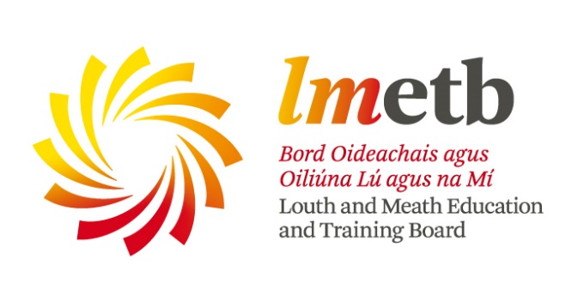

**EXPRESSIONS OF INTEREST**

**External members of Finance Committee**

Applications are invited from those who wish to be considered to be nominated as external members of the LMETB Finance Committee.

The Committee will serve from 2024 to 2029 and is required to have three to five external members. These external members, together with up to three members who are also members of the LMETB Board, will constitute the Committee.

LMETB is a statutory authority with responsibility for education and training, youth work and a range of other statutory functions in Louth and Meath. LMETB manages and operates community national schools, second-level schools, further education colleges and a range of adult and further education and training centres throughout Louth and Meath including the Advanced Manufacturing Training Centre of Excellence and the Regional Skills and Training Centre in Dundalk and the Drogheda College Electrical Apprenticeship Centre. LMETB’s expenditure in 2023 was €230 million.

The expression of interest form and other relevant documents are available under latest news at [www.lmetb.ie](http://www.lmetb.ie).

Applicants should submit a completed form to: Louth and Meath Education and Training Board, Abbey Road, Navan, County Meath to arrive not later than noon on Friday 2nd August.

The envelope should be clearly marked “Finance Committee”.

**Martin G. O’Brien, Chief Executive Officer**

**Louth and Meath Education and Training Board**