**Guide for Employers Handbook**

**National Apprenticeship in Robotics & Automation**

**QQI Level 6 Programme**

# HELLO AND WELCOME

Congratulations on your appointment as a registered apprentice employer for the new Robotics and Automation Apprenticeship Programme. Your role will be instrumental in the development of the career of your apprentice(s) who will require encouragement and support over the next 2 years. The Robotics and Automation Management team are here to support and guide you too!

Many of today’s industry leaders have publicly acknowledged the support and guidance their employers have given them and have articulated the value of their investment of time and energy in supporting them in the early stages of their careers. Effective recruitment, selection, and ongoing support of apprentices through to the completion of their training, ensures a talent pipeline of skilled workers capable of meeting the business challenges of the Advanced Manufacturing as they adopt Industry 4.0 technologies. The adoption of technologies such as Robotics and Automation systems are changing the manufacturing sector.

Whether your organization decides to extend the skills of existing staff or to recruit new employees, your business will benefit from this apprenticeship programme. Therefore, it is in their best interest to nominate a suitably qualified and dependable employee to act as a mentor to the apprentice. In this context your new role is key to achieving success both for the company and crucially for the apprentice.

This handbook is designed to assist you to develop the Robotics and Automation apprentice within your organization by enhancing your mentoring and coaching skills during their on-the-job training phase of the programme. In addition, LMETB (Louth Meath Education and Training Board) are committed to supporting you in this role on an ongoing basis and contact details of relevant personnel can be found within this handbook.

We look forward to collaborating with you and would like to thank you for the significant contribution you are making to ensure the Robotics and Automation apprentice experiences a supportive learning environment throughout the duration of the programme.



[Find us on Google Maps](https://www.google.com/maps/place/Advanced+Manufacturing+Training+Centre+of+Excellence+(AMTCE)+(LMETB)/@53.9762235,-6.3979326,17z/data=!3m1!4b1!4m6!3m5!1s0x4860cdb7d3a6570d:0x847692419e471cae!8m2!3d53.9762235!4d-6.3979326!16s%2Fg%2F11q1rt14gp?entry=ttu)

Building B, Xerox Technology Park, Dundalk, A91 Y319

# PROGRAMME CONTACTS

|  |  |  |  |
| --- | --- | --- | --- |
| **Role** | **Named Contact** | **Contact email** | **Contact number** |
| **Chairperson of Consortium Steering Group (CSG)** | Barry Kennedy |  |  |
| **Programme Manager** | Adrian Kelly | akelly.amc@lmetb.ie | 086 083 8005 |
| **Co-ordinating Tutor** |  |  |  |
| **College Mentor** |  |  |  |
| **Tutor/s** |  |  |  |
| **Tutor/s** |  |  |  |
| **Workplace Mentor** |  |  |  |
| **Workplace Coordinator** |  |  |  |
| **SOLAS Authorised Officer** | Paul Doody | Pdoody.amc@lmetb.ie | 0861684694 |
| **Programme Quality Manager** | Kelvin Harvey/Paula Quinn | [Kharvery.amc@lmetb.ie](mailto:Kharvery.amc@lmetb.ie)  Pquinn.amc@lmetb.ie |  |

Contents

HELLO AND WELCOME 2

PROGRAMME CONTACTS 3

1 SOME DETAILS ABOUT THIS APPRENTICESHIP PROGRAMME 6

2 RATIONALE FOR PROVIDING THE PROGRAMME 7

3 CONSORTIUM STEERING GROUP 8

4 PROGRAMME AIMS AND OBJECTIVES 9

4.1 Programme Structure 10

4.2 Learning Outcomes 10

4.2.1 Programme Aim / Purpose 10

4.2.2 Programme Objectives 10

4.2.3 Minimum Intended Programme Learning Outcomes (MIPLOs) 11

5 PROGRAMME BOARD – MEMBERSHIP AND TERMS of REFERENCE 11

6 EMPLOYER REGISTRATION 13

6.1 Employer Registration Journey 14

6.2 The Apprentices Admissions Journey 15

7 EMPLOYERS DUTIES AND RESPONSIBILITIES 16

7.1 Programme Costs 16

7.2 Key Employer Considerations 16

8 MENTOR 16

9 SOLAS AUTHORISED OFFICER 17

10 THE ROBOTICS AND AUTOMATION APPRENTICE DEFINED 18

Profile of Learners 18

Minimum Entry Requirements 18

11 NATIONAL FRAMEWORK OF QUALIFICATIONS 19

13 WE ARE HERE TO SUPPORT YOU AND THE APPRENTICE ON THIS EXCITING JOURNEY 22

# SOME DETAILS ABOUT THIS APPRENTICESHIP PROGRAMME

* This apprenticeship is a two-year level 6 programme designed and developed in collaboration with the programme Consortium Steering Group, consisting of representatives from the Robotics & Automation industry, Advanced Manufacturing sector, Industrial Research, Unions, and education Providers.
* The programme is targeted at companies who provide Robotics and Automation solutions and companies in the Advanced Manufacturing Sector who use these solutions.
* It is suitable for those currently employed in these companies, school leavers, career switchers and mature applicants wishing to pursue a career as a qualified Robotics and Automation Technician.
* The modules in the apprenticeship will give the apprentice, the knowledge and a range of robotics and automation skills.
* The programme has been conceived and developed through an Industry led Consortium and engagement with work-based learning experts.
* The apprenticeship programme includes nine modules, concludes with a capstone project in line with the company processes and procedures. Cross reference on PDT
* Upon completion of the programme, successful apprentices will graduate with an Advanced Certificate in Robotics and Automation at Level 6 on the (QQI) National Framework of Qualifications.

# RATIONALE FOR PROVIDING THE PROGRAMME

The emerging and apparent skills storage across the advanced manufacturing sectors are considered as having a significantly negative impact on the capacity for growth despite there being a buoyant and expanding global marketplace. The named consortium proposes to develop a national Robotics and Automation Apprenticeship Programme (RAA) as a timely means to address some of the emerging skill needs - through devising a new and appropriate dual education FET award at NFQ Level 6.

The proposed national Robotics and Automation Apprenticeship Programme is fully aligned to key and relevant National and Regional Government Strategies, Policies and Actions regarding workforce development and industrial policy as articulated in the following publications:

1. Future Jobs Ireland 2019: Preparing Now for Tomorrow’s Economy.
2. Technology Skills 2022: Ireland’s Third ICT Skills Action Plan
3. The Expert Group on Skills Needs Report-Digital Transformation: Assessing the impact of Digitalisation on Ireland’s Workforce.
4. FIT ICT Skills Audit 2018
5. Supporting Working Lives and Enterprise Growth in Ireland 2018
6. SOLAS Skills to Advance 2019 – 2021
7. SOLAS Further Education and Training Strategy 2020 – 2024
8. Ireland’s Industry 4.0 Strategy 2020 – 2025
9. Manufacturing in Ireland 2023 (IBEC)

The industrial revolution of today, known as Industry 4.0/5.0, is driven by the interconnectedness of advanced technology, automation, robotics, and real time data via the Industrial Internet of Things (IIoT). While industrial cyber-physical systems can autonomously exchange information to trigger actions and make decentralised decisions, it is impossible to dismiss the importance of the human factor in manufacturing process as emphasised by Industry 5.0.

Industry 4.0/5.0 are characterised by the integration of digital connectivity and advanced technologies, giving rise to automated industrial systems and smart production processes that boost efficiency across supply chains. The advanced technologies and process that direct, manage and maintain machine operations, gather data, and make decentralised decisions work in concert with employees to create what is often called a “smart shop floor.”

At consumer level, they have manifested as smart home devices and voice-enabled technologies. At societal level, they are fuelling the growth of small cities, revamping public services. While big companies are leveraging digital technologies throughout their extensive operations, these tools are also democratising manufacturing by allowing the entry of smaller players into the sector while supporting sustainability through facilitating bespoke production.

The key challenge emerging in the context of ‘advanced’ or ‘smart’ manufacturing is the optimal cooperative interactivity of humans, robotics, machines, and ICT systems. Thus, production technologies, production processes and organisation, as well as human resources development, are regarded as equally important. The RAA will develop a complementary FET Level 6 programme to enhance the talent pipeline for the manufacturing, robotics, automation, and systems integration sectors as part resolution to the growing and concerning skills shortages across these sectors.

# CONSORTIUM STEERING GROUP

The Consortium Steering Group (CSG) comprises of the key stakeholders in the RAA apprenticeship programme namely, employers, occupational associations and regulatory interests, training providers and the Coordinating Provider. The essential role of the CSG is to guarantee that the RAA apprenticeship programme is enterprise-led, responsive to pertinent and emerging occupational requirements and satisfies current and future labour market requirements.

The Coordinating Provider for the Apprenticeship plays a lead role in liaising with the employers and other providers through the Consortium Steering Group. With respect to the delivery of the RAA apprenticeship, LMETB, represented by the Board of the Advanced Manufacturing Training Centre of Excellence is the Coordinating Provider and consortium lead, and the consortium is largely comprised of the Board Members.

The CSG has a key role in the development and review of the occupational profile and in promoting public awareness of that profile. The CSG ensures that the apprenticeship programme complies with the requirements of the occupation and thereby plays a critical role in the development and review of the occupational profile and in promoting public awareness of that profile and is a mandatory governance requirement for validating apprenticeship programmes with QQI.

In collaboration with the statutory regulator, the CSG should guarantee that the essential component of 'on-the-job' training is upheld and administered at the suitable level with the determined learning objectives and that it is applied competently by employers and by the Coordinating Provider. It functions as a connection between employers and the Coordinating Provider at a wide level.

The CSG is chaired by an industry representative with extensive experience in the sector.

The Consortium Steering Group is part of the overall national development structure of all new apprenticeship programmes. The role, membership, and purpose of the CSG are set out in QQI Topic Specific QA Guidelines for New Apprenticeships.

The CSG contributes to the decision-making process in collaboration with the ETB and national stakeholders on the expansion of apprenticeships, and the addition of new employers and providers. Approval for establishment of the Consortium Steering Group is vested in the National Apprenticeship Alliance.

On validation of the programme, the role of the Consortium Steering Group will transition from a developmental role in the establishment of the occupational profile and the appointment of a Coordinating Provider, to a continuing role in supporting and improving the validated apprenticeship programme. To conduct this role the CSG will interact with employers, the regulatory authorities, the occupational bodies, the National Programme Board and the Coordinating and Collaborating Providers.

# PROGRAMME AIMS AND OBJECTIVES

The Robotics and Automation Apprenticeship (RAA) programme aims to provide Apprentices with the skills, knowledge, competencies, and practical application to secure and retain quality employment in advanced technician roles across the various advanced manufacturing sectors including engineering, food & drinks, pharma etc.

A Robotics and Automation Technician designs, installs supports, and maintains the on-demand availability of both robotic and factory automation systems.

RAA’s will be trained and qualified to manage, monitor, and maintain automated manufacturing equipment and assembly processes, monitor and check product quality and document results in adherence to prescribed protocols and safety procedures in a discrete manufacturing environment. Training and tasks undertaken by RAA’s will relate to:

* Setting up, operating, and maintaining robotic cells and industrial control systems; running and real-time monitoring of equipment outputs, overseeing highly automated manufacturing cells or processes e.g., IIoT plant and machinery, tablet manufacturing or automated production and packaging process, CNC machine centres, automated welding cells etc.
* Overseeing, monitoring and maintenance of automated assembly lines or assembly stations.
* Relevant knowledge and familiarity with automated manufacturing processes to oversee and troubleshoot at an appropriate level in consultation senior members of staff as prescribed by operational procedures.
* Maintain robotics systems and associated equipment e.g., robotic welding stations in good working order by performing regular inspection, cleaning, servicing along with preventative and predictive maintenance interventions.
* Perform systems upgrades including application and firmware updates and patching.
* Maintain accurate and clear documentation that proves that systems are being maintained in accordance with both internal and external quality systems or regulations.
* Keep maintenance logs for the equipment or processes they oversee, which requires proficiency in technical writing, word processing and spreadsheet software.
* Provide regular productivity reports, and incident reports if an accident occurs.
* Follow strict internal protocols and Standard Operating Procedures (SOPs) as well as following current Good Manufacturing Practices (GMP) when working with the pharmaceutical and medical device manufacturing industry.

The proposed RAA on completion will equip robotics and automation technicians with key skills and traits including:

* Key technological competencies and relevant computer skills.
* Robotics and automation operations, process, and maintenance skills.
* Production Process Capabilities
* Ability to apply a safety mindset to all aspects of the role.
* Engineering and PLC competencies
* CAD/CAM Competencies
* Proficiency in Technical Documentation
* Mathematical, Numerical & Measurement Competencies
* Knowledge of IIoT Technologies Implementation, Monitoring and Maintenance
* Good Communication, Interpersonal and Team skills.

## Programme Structure

The programme structure facilitates delivery in four phases preceded by a workplace-based induction and programme orientation period. The overall programme is designed so that the apprentice spends 70% of their time on-the-job and 30% off-the-job.

## Learning Outcomes

It is the policy of LMETB to manage the development of a teaching and learning strategy to deliver relevant, high-quality programmes to apprentices and to enhance apprentice learning and progress, both on and off-the-job.

All new national apprentice programmes are required as part of QQI validation process to have an associated set of Minimum Intended Programme Learning Outcomes (MIPLOs) and Minimum Intended Module Learning Outcomes (MIMLOs).

### Programme Aim / Purpose

The Robotics and Automation Apprenticeship programme aims to provide a dedicated and practical programme for learners wishing to secure and retain employment in a robotics and automation technician role.

### Programme Objectives

1. To provide apprentices with a broad knowledge of robotics and automation in the advanced manufacturing sector.
2. To provide apprentices with related specialised knowledge, a safety mindset, practical skills, and competence for autonomous professional practice as a robotics and automation technician.
3. To enable apprentices to fully participate in the related professional community of practice.
4. To provide apprentices with the skills to evaluate information and evidence and to generate creative solutions to problems arising in their professional activity.
5. To develop the ability for apprentices to exercise autonomy, judgement, and responsibility in applying their knowledge and skills in compliance with safety requirements.
6. To enable apprentices to communicate effectively and to achieve a professional standard of communications across various forms of technical and non-technical communications.
7. To provide apprentices with the ability to act effectively in team roles, exercise supervision, lead activities and contribute to development of the workplace and the performance of others.

### Minimum Intended Programme Learning Outcomes (MIPLOs)

On completion of this programme, the learner (apprentice) will be able to:

1. Identify and appraise the key elements and principles of advanced manufacturing and industry 4.0/5.0. and the fundamentals and benefits of robotic systems.
2. Evaluate problems and develop solutions autonomously in the design, programming, system integration and use of robotic systems while adhering to health and safety regulations and guidelines.
3. Adhere to a safety mindset in their own professional activity and be able apply the relevant safety concepts, regulations and standards that apply to automation and robotic systems within the context of the community of practice.
4. Demonstrate an ability to apply tools and techniques to the digitisation of the design, maintenance, and optimisation of manufacturing processes with due regard to ethical considerations.
5. Apply knowledge, initiative, good decision making autonomously, and the practical hands-on skills required to operate, maintain, calibrate, troubleshoot, and upgrade industrial systems and engineering workshop processes.
6. Describe various types of control systems used in manufacturing and robotics; and how to configure, programme, maintain and troubleshoot them.
7. Use a range of mathematical techniques to solve problems and describe how this approach can be applied to improve manufacturing processes.
8. Work effectively as an individual, in teams and lead others in the field of advanced manufacturing, robotics and automation, taking responsibility for their own work while continually engaging in ongoing learning and professional development.
9. Communicate complex information effectively in both technical and non-technical contexts.

Manage and evaluate their own learning and help others to identify their needs in the context of the potential impact of the technologies and how they are used.

# PROGRAMME BOARD – MEMBERSHIP AND TERMS of REFERENCE

The Programme Board is responsible for the oversight of the RAA apprenticeship programme and reports to LMETB’s QAGMC (QA Governance Management Council). It has access to information and data on the execution of the programmes, the assessment results, and the mobility of apprentices through the components of the programme. It receives all procedural reports from collaborating providers and from independent examiners and is cognisant of the circumstances of the collaborating providers and in the occupation.

The Programme Board is representative of relevant employers nationally utilising robotics and automation in the manufacturing process and education and training providers, apprentices, and stakeholders to advise on the programme proposal and operation. The Programme Director is a member of the Programme Board and will function as secretariat liaising with the consortium and awarding body as required.

The Programme Board will assist the Consortium Steering Group in ensuring the RAA programme is informed and led by the current and future requirements of enterprises.

The Programme Board is the single national entity with responsibility for the eﬀective management, operation, monitoring, and review of the Apprenticeship Programme.

Day to day oversight of the operation of the validated apprenticeship programme

* Establish a Recognition of Prior Learning (RPL) Committee, where required, to manage the operation of RPL as it applies to the programme, as validated.
* Devise / approve the assessment strategy and types of assessment to be used in a programme cycle to ensure that the module outcomes are being assessed, that cumulatively the MIPLOs are assessed.
* Generate a bank of assessment resources.
* Agree the assessment schedules for the programme on the advice of the Programme Manager.
* Consider inputs from the External Authenticator on issues of delivery and assessment. This will be done on receipt of the External Examiner’s report and in advance of new cycle starting.
* Consider reports from Collaborating Providers, Workplace Mentors, and teachers on the progress of apprentices and on delivery and assessment of the approved programme.
* Encourage the sharing between workplace mentors and providers of best practice in the delivery and assessment of apprentices.
* Consider the eﬀectiveness of the teaching, learning and assessment strategies being implemented as per the validated programme.
* Ensure as far as possible that the apprentices in each centre get an equivalent experience.
* Programme monitoring, review, and improvement:
  + Agree and implement minor modifications and additions to the programme where these do not aﬀect module outcomes. This will include suggestions from the External Authenticator, or improvements suggested by mentors or by teachers.
  + Monitor the on-going operations of the programme nationally.
  + Monitor examination and continuous assessment results nationally to ensure an appropriate mix of learning modes and associated assessment methods.
  + Seek feedback from significant stakeholders on the delivery of the programme and on possible minor modifications.
  + Regularly consider results of surveys of apprentices and other stakeholders of programmes.
  + Contribute to the occupational review process.
  + Suggest necessary equipment and facilities requirements and upgrades as well as skills enhancement initiatives.
  + Examine the eﬀectiveness of support services such as administrative services and Moodle.
  + Make recommendations on the use of existing resources and the need for added resources.
  + Introduce improvements in the programme arising out of the monitoring and review process.
  + Perform a detailed self-evaluation of the operation of the Programme Board periodically (usually every five years)
  + Suggest appropriate external experts to play a role in designing, monitoring, and reviewing programmes.
  + Recommend appropriately qualified persons as External Authenticators.

# EMPLOYER REGISTRATION

There are two stages for employers interested in participating in the programme.

**STAGE 1:**

An Employer interested in participating in the programme and employing an apprentice should:

* + Complete an Expression of Interest (EOI) form available at www.apprenticeship.ie and return it to the Programme Manager
  + Following receipt of the EOI the Programme Manager and a nominated subject matter expert will conduct a site visit to brief the employer on the requirements and assess the employer’s capacity to deliver the on-the job training.
  + Following the site visit and evaluation of the employer’s capacity to deliver the on-the-job elements of the curriculum, the Programme Manager will forward a report to the SOLAS AO / TA
  + The employer will be required to complete a Memorandum of Understanding, governing the general terms relating to the participation in the RAA apprenticeship programme.

*Note: When assessing employers for any specific programme, consideration will be given to the allocation of places available in each programme in accordance with sectoral and geographical quotas agreed in advance.*

**STAGE 2:**

The AO / TA will proceed with the statutory SOLAS Employer Approval process including:

* + Conducting a site visit and completing the statutory paperwork required for companies seeking approval to train apprentices. This will include reviewing and advising on the Code of Practice for Employers
  + Where deemed suitable, the SOLAS AO / TA recommends the employer to SOLAS for statutory approval to train apprentices as RAA Technicians
  + Following SOLAS confirmation, the employer is statutorily authorised to employ an apprentice and formal correspondence is issued from SOLAS.

For more information on the Irish apprenticeship system please visit [www.apprenticeship.ie](http://www.apprenticeship.ie)

## Employer Registration Journey

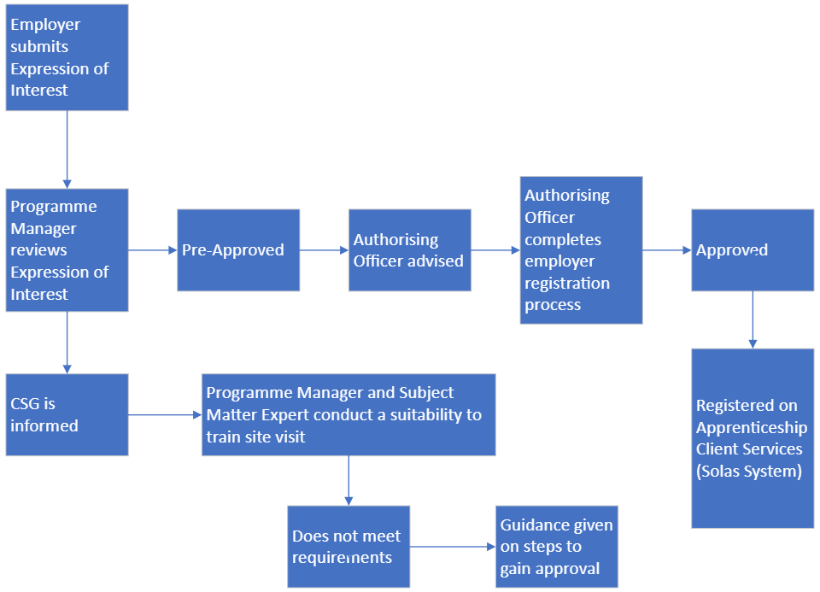

## The Apprentices Admissions Journey

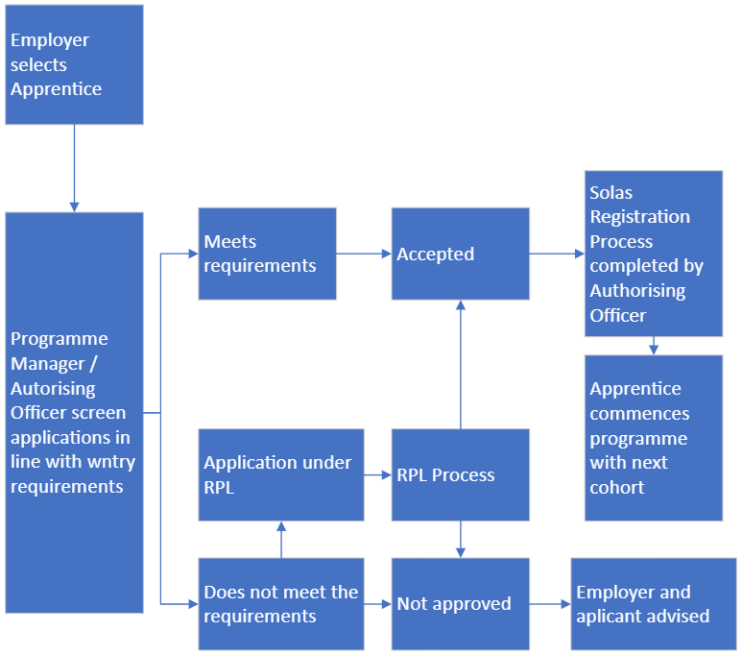

# EMPLOYERS DUTIES AND RESPONSIBILITIES

## Programme Costs

There is no cost to the employer or apprentice for participation in the programme delivery off-the-job. All fees associated with the training will be covered by SOLAS. It is up to each employer to set the salary scale and pay for the apprentice. It is the responsibility of the employer to cover fulltime employment costs of the apprenticeship both during the on-the-job and when the apprentice is participating in the off-the-job training. These costs also include travel costs.

## Key Employer Considerations

* Has your company the capacity to recruit and employ the apprentice on a two-year fixed, full-time contract including the block release training?
* Can your company provide the apprentices with access to a range of work that will allow them to develop their skills and increase their experience across a range of competencies that are included in the training plan? If you cannot provide the full range required contact the Programme Manager for assistance.
* Can your company provide the apprentice with the facilities, equipment and time required for them to complete their on-the-job and off-the-job learning?
* Can your company identify and provide a suitably qualified and experienced Mentor, who will support and guide the apprentice, oversee the training, and verify that the apprentice is receiving the required experience in the workplace?

# MENTOR

The importance of you as a Mentor

The Workplace Mentors have responsibility for training, completing work-based assessments, recording, and processing assessment checklists and on-the-job schedules as specified in the work-based assessments schedule for the on-the-job phases of the apprenticeship.

Assigned Mentors should be qualified individuals with experience in the discipline who can guide, advice and support their designated apprentice personal, technical, and professional development in the workplace. Mentors are also charged within ensuring apprentices are allocated the time and resources to complete all workplace projects and assignments in accordance with the programme schedule.

They will occupy a role in the workplace that corresponds to a senior practitioner level. They will be appointed by the employer and approved by the SOLAS Authorised Officer supported by the Programme Manager as required.

Nominated Workplace Mentors must attend a mandatory Mentoring Training Programme which will be delivered by the Coordinating Provider to ensure that they understand their responsibility in relation to training and assessing an apprentice on-the-job, to industry and awarding body standards.

A network of SOLAS AOs / TAs based in ETBs manage and support approved companies and apprentices within their region on behalf of SOLAS. The SOLAS AOs / TAs are independent office holders who collaborate with employers, apprentices, and other stakeholders to facilitate the rollout of national apprenticeships for SOLAS.

They have responsibility for assessing and approving employers to register and train apprentices2 and for registering apprentices and monitoring employers during the on-the-job phases. All records relating to employers and apprentices on national apprenticeships are managed by the Authorised Officers.

# SOLAS AUTHORISED OFFICER

A network of SOLAS Authorised Oﬀicers based in ETBs manage, support, and administer a portfolio of apprentice approved companies and apprentices within their region on behalf of SOLAS. They operate under a certificate of appointment as SOLAS Authorised Oﬀicers by the Chief Executive Oﬀicer of SOLAS under section 43 of the Industrial Training Act 1967, as amended.

The SOLAS Authorised Oﬀicers provide an independent brokerage through which the integrity of the overall Apprenticeship programme is maintained and are a critical link between the Co-ordinating and Collaborating Providers, the apprentice, and the employer. They currently conduct a range of functions on behalf of SOLAS including, but not limited to:

* Conducting an assessment site visit to assess the employer’s suitability to train apprentices.
* Briefing employers on their roles and responsibilities in relation to the on-the-job elements of the apprenticeship on behalf of the statutory regulator. Assessing and approving employers to register apprentices, through SOLAS Employer Approval and Code of Practice
* Approving and registering new apprentices and apprentices changing employers
* Providing an objective information and guidance service to all apprentices registered
* Monitoring of employers during the apprentice’s on-the-job phases
* Maintaining apprentice and employer records.
* Collaborate and communicate with the National Programme Manager in the delivery of the Programme.

Louth & Meath Education and Training Provider as Co-ordinating Provider, will work in collaboration with the network of SOLAS Authorised Oﬀicers and will fully brief them on the programme-specific criteria for employer suitability to train apprentices, as outlined in the validated programme documentation. On validation of the programme, a schedule of briefings will be conducted for SOLAS Authorised Oﬀicers by the National Programme Manager and National Programme Board representatives.

# THE ROBOTICS AND AUTOMATION APPRENTICE DEFINED

The graduating RAA technician will be a general practitioner of a range of skills. Specialist skills would be called upon if outside the certified competence of the Robotics and Automation technician. This type of apprenticeship has not existed heretofore, unlike many of those that have previously been approved.

## Profile of Learners

The Robotics and Automation Apprenticeship is designed to suit learners with an aptitude for, and an interest, in engineering and manufacturing. The apprenticeship model, “Earn While You Learn,” offers an excellent alternative to those interested in engineering, in particular the practical element, and who do not want to continue their education in Higher Education institutions. The apprenticeship is promoted to both male and female students. LMETB actively engage with schools, teachers, Guidance Counsellors, the Engineering and Technology Association (ETTA), as well as parents and guardians to increase the awareness of the programme, career possibilities following completion of the apprenticeship and all benefits associated with choosing this course.

The programme is available to all learners who are employed and registered with SOLAS as Robotics and Automation apprentices whilst meeting the minimum educational entry requirements.

## Minimum Entry Requirements

Entry Criteria: make as clear as possible, how you will identify those apprentices who have a reasonable chance of succeeding on this programme. make as clear as possible, how you will identify those apprentices who have a reasonable chance of succeeding on this programme. If there are numeracy and/or language requirements, they should be made clear.

Minimum entry requirements are as follows:

* + - Learners wishing to enrol on the RAA Apprenticeship programme must be 17 years or older and have achieved a passing grade (O6/H7) in five or more subjects (to include Maths and English) at Ordinary Level in the Irish Leaving Certificate, or a suitable equivalent qualification. For those who may not hold this certification, equivalence may be decided through a Recognition of Prior Learning procedure.
    - CERFL proficiency at B2 for those whose first language is not English.
    - Additional requirements may apply to non-EU/EA learners. Please refer to Labour Market Access Permission - Immigration Service Delivery (irishimmigration.ie)

Candidates may be required to complete an RAA specific application form, undergo an appropriate aptitude assessment, and take part in an interview held by a Collaborating Accepted Employer

**Skills and attributes are as follows:**

Prior to commencement candidates must complete the statutory apprenticeship registration process. Prospective Learners on the RAA Apprenticeship programme must be numerate, literate, and interested in robotics and automation and in pursuing a career in advanced manufacturing. They should possess excellent communication skills, excellent interpersonal skills, and an ability to work in a team. They should display an interest in and a capacity to absorb product knowledge and related technical competencies. They should demonstrate motivation to commence and complete the RAA apprenticeship programme within the timeframe specified.

Learners wishing to enrol on the RAA Apprenticeship programme should notify their prospective employer during the application process if they require any reasonable adjustments (i.e., provisions for physical or unseen impairments or a requirement for additional aid to utilise technology during the application process or during the programme of training). This should be immediately communicated to LMETB (AMTCE) prior to commencement on the programme.

# NATIONAL FRAMEWORK OF QUALIFICATIONS

The national framework of qualifications (NFQ) is an approved framework through which learning achievements can be measured and related to come together in a coherent way.

Qualification frameworks describe the qualifications of an education and training system and how they interlink. As described by Quality and Qualifications Ireland (QQI) “the Irish NFQ, established in 2003, is a framework through which all learning achievements may be measured and related to each other in a coherent way. The many different types and sizes of qualifications included in the NFQ, are organized based on their level of knowledge, skill, and competence. Because all NFQ qualifications are quality assured, learners can be confident that they will be recognized at home and abroad.” (Reference <https://www.qqi.ie/what-we-do/the-qualifications-system/national-framework-of-qualifications>)

Rationale for the choice of QQI named award stem sought and for the named award title QQI level 6 was considered by the consortium as the most appropriate level for new entrants, who wish to develop a pathway within the Robotics and Automation Sector.

The level of education was certified by QQI at level 6 on completion of a robust programme validation process.

# WE ARE HERE TO SUPPORT YOU AND THE APPRENTICE ON THIS EXCITING JOURNEY

Contact details (Details need to be confirmed for RAA)

AMTCE Manager

Programme Manager