
LMETB Assessment
Malpractice
Procedure

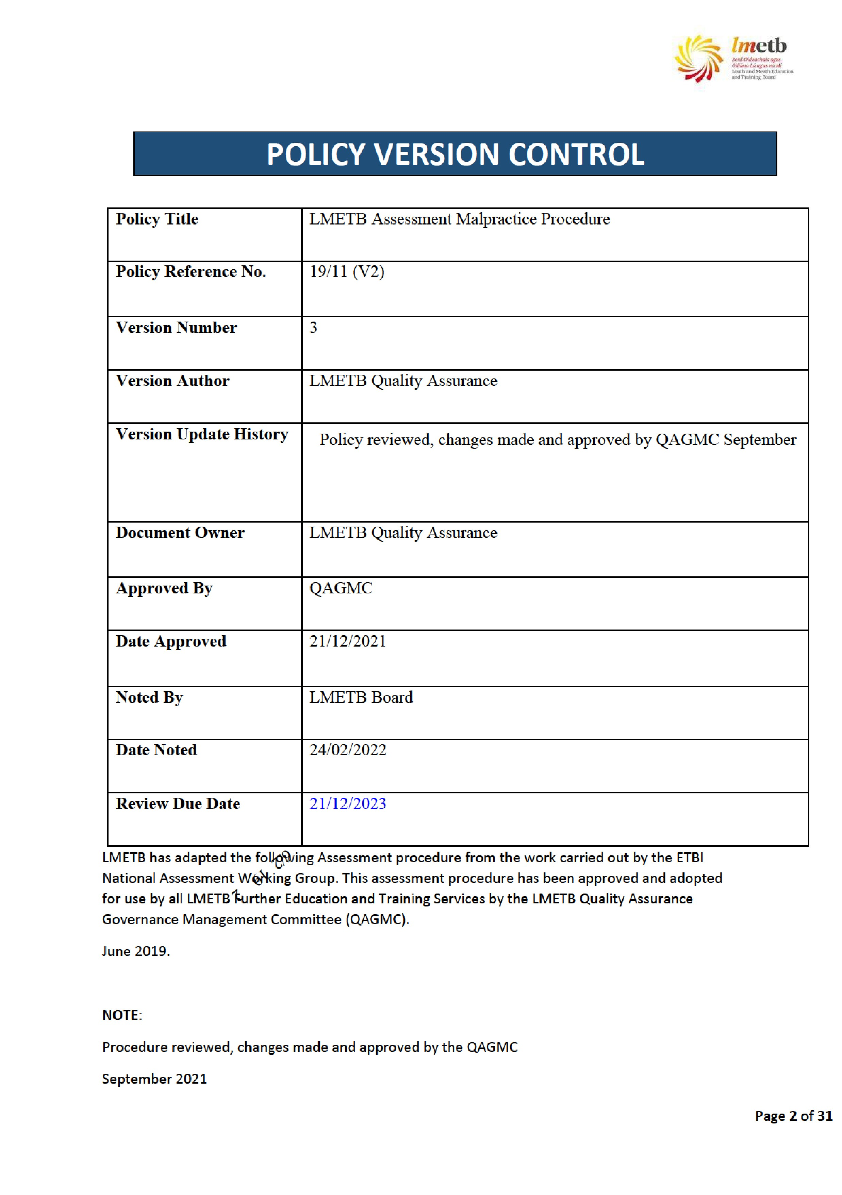
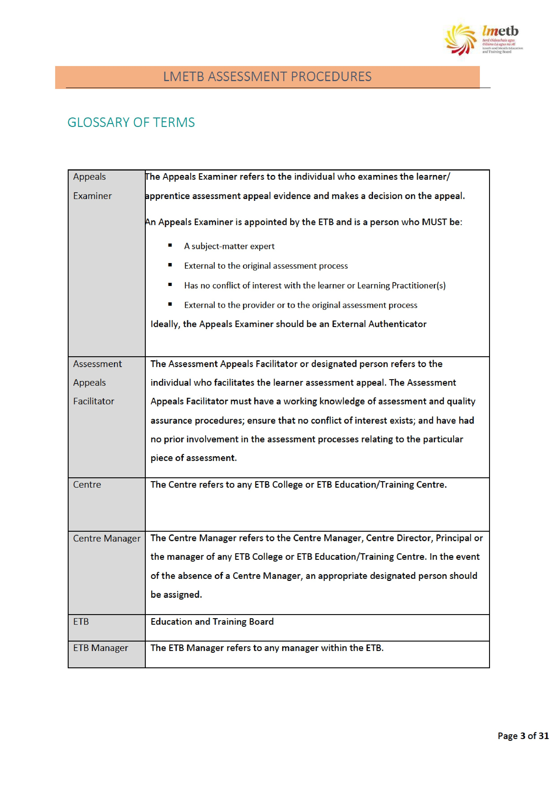



Independent
Appeals
Committee
Invigilator
The Independent Appeals Committee refers to the committee which exam
i
nes
the assessment process appeals. The committee is appointed by the ETB and
MUST:
•
Consists of a minimum of two
ETB
senior personnel who are external to
the Centre
•
Have knowledge of QA procedures
The Independent Appeals Committee should be supported by internal QA
personnel.
Depending on the nature of the appeal, personnel from outside the ETB may be
required. This is at the discretion of the ETB.
The Invig
i
lator refers to the individ
u
a
l
who supervises an examination.
Ideally, an alternative invigilator other than the Learning Practitioner
should supervise an examination.
The Invig
i
lator (appointed by the Pr
,
ogramme Co-ordinator) must:
•
sign a declaration of impartiality
•
be appointed in line with the specific guidelines of the awarding body,
if such guidelines exist.
Learning
Practitioner
The Learning Practitioner term refers ito all teaching staff
and
includes
Lecturer/Instructor/Contracted Trainer,
facilitators etc.
Programme Co-
The Programme Co-ordinator refers to Programme Co-ordinator, Programme
ordinator
Manager or other relevant manager of course or programme. In the event of
the absence of a Programme Manager, an appropriate designated person
should be assigned.
RPL Mentor/
_{Facilitator}
The RPL Mentor/Facilitator refers to an individual who:
•
is familiar with
RPL
policies
•
•
has received training in
RPL
is a subject matter expert
Page 4 of 31

ASSESSMENT MALPRACTICE

Principles of Assessment in Relation to Assessment Malpractice
Quality assured assessment ensures that in criterion referenced assessment “learners are assessed and the assessment judgment is made based on whether the learner /apprentice has reached the required national standards of knowledge, skill and competence for the award” (QQI, Revised 2018 p.5). Central to quality assured assessment is the assumption that learners are assessed in a fair and consistent manner in line with the award standard. Quality assured assessment ensures adherence to the principles of assessment.
The following sets forth the principles of assessment which apply to this document: these principles are based on the QQI (Revised 2018) principles for assessment.

Validity
Validity is a fundamental assessment principle ensuring that an assessment measures what it is designed to measure: the relevant standard of knowledge, skill or competence required for an award should be assessed.
Validity in assessment occurs when:
- Assessment is fit for purpose (i.e. a practical assessment assesses a practical skill)
- Learners can produce evidence which can be measured against the award standard
- Assessors can make accurate assessment decisions
- Assessment is accessible to all candidates who are potentially able to achieve it

Reliability
Reliability in assessment ensures that assessment measurement is accurate: the knowledge, skills and competence which the assessment measures should produce reliable and accurate results. Reliability in assessment ensures that results are consistent under similar conditions.
Reliability in assessment occurs when:
- The assessment is based on valid assessment techniques
- Assessment conditions are consistent
- Learner evidence is reliable
- Results are consistent across various assessors, contexts, conditions and learners over time.

Fair
Fairness in assessment supports the validity and reliability principles and provides equal opportunity to all learners/apprentice candidates. Fairness in assessment ensures learners / apprentice candidates have access to appropriate resources/equipment in assessment; assessment design and implementation are fair to all learners/apprentice candidates; and policies and procedures exist to ensure fair assessment of learners/apprentice candidates.
Quality
Quality in assessment ensures that all assessment processes are quality assured.

Transparency
Transparency in assessment ensures that assessment policy and procedures provide clarity to all relevant stakeholders.
Based on QQI Principles for Assessment (QQI, Revised 2018)
Assessment is underpinned by the principles of assessment including the fair principle (equal opportunity for all learners) and consistent principle (consistency in approach to assessment across LMETBs, programmes and modules). As such, in order to ensure the fair and consistent assessment of learners/apprentices, the following procedure should be followed in relation to any suspected malpractice cases.

Definitions

Assessment System Irregularity and Assessment Malpractice
It is important to distinguish between assessment system irregularity and assessment system malpractice. The decision on whether an issue is deemed to be considered an assessment system alleged irregularity or malpractice will relate to the intent, scale or fraudulent nature of the incident by the offender. An issue that may initially be adjudged to be an assessment system irregularity could, after preliminary investigation, be determined to be an alleged malpractice issue. Where such an issue is deemed to be an alleged malpractice, the procedures outlined in this document must be utilised.

Definition of Assessment System Irregularity
Assessment system irregularities are typically accidental omissions or mistakes which are detected by mechanisms within the assessment system, are corrected, and which do not impact on the validity of the assessment. These could include test administration errors, missing assessment data, errors in transcription etc. which are detected and rectified. All instances of irregularities should be documented and addressed in line with this procedure.

Definition of Assessment Malpractice
An assessment system malpractice is any act or practice which brings into question the validity or integrity of the assessment process and which normally arises due to one or more non-accidental factors.
Two categories of malpractice exist:
Learner/Apprentice/Candidate Malpractice
Staff Malpractice
This procedure relates to Learner/Apprentice Malpractice only.
Learner /Apprentice Candidate Malpractice
Learner Malpractice is defined as malpractice committed by a learner/ Apprentice Candidate during the course of the assessment process.
Examples of learner /Apprentice Candidate malpractice include but are not limited to:

Plagiarism
Learner/Apprentice plagiarism is defined as the practice of Learners/Apprentice Candidate submitting any work for assessment that is not their own original work. This could be any percentage of work that has not been referenced and has been copied from published work, the internet, artificial intelligence technology (AI), other learners’ work and/or other sources. Plagiarism in assessment may include but is not limited to:
- Representing work completed by and/or authored by another person (including other learners, family, work colleagues and friends) as their own
- Procuring work from a company or external source including the internet/AI.
- Copying work from any source or medium without reference (i.e. website, book, journal article, AI.)
- Taking a passage of text, or an idea, and summarising it without acknowledging the original source
- Passing off collaborative work as one’s own
- Piecing together sections of others’ work into a new whole
- Submitting another learner’s work with or without their knowledge.
The submission of such plagiarised materials for assessment purposes is fraudulent and all suspected cases will be investigated and dealt with appropriately using the procedures outlined in this document.
Suspected cases of plagiarism will only be investigated when there is a declaration of authenticity which has been signed by the learner. Any electronic assessment submitted is deemed as having been declared as authentic by the learner.
and/or

Unacceptable Behaviour
Unacceptable behaviour in assessment may include but is not limited to:
- Unauthorised removal of assessment material from the assessment location
- Deliberate damage to or destroying of assessment related materials
- Use of electronic communication device/technology or other unauthorised materials during the assessment
- Assisting other learners during the assessment
- In an assessment event (e.g. examination), any form of communication with other learners (written, verbal, gestures, expressions, pointing, etc.)
- Collusion by working collaboratively with other learners, beyond what is allowed
- Copying from another learner (both parties involved in the investigation)
- Fabrication of results and/or evidence
- Falsification (faulty data collection methods)
- Behaving in such a way as to undermine the integrity of the assessment event or process.
- Impersonation by pretending to be someone else in order to produce the work for another or arranging for another to take one’s place in an assessment
- Engaging in unsafe practices in assessment
- Disruptive, violent and offensive behaviour in relation to assessment
- Tampering or interfering with assessment materials or another learner’s work
- Submission for assessment of a piece of work that has been purchased/procured from another source where the work is not the learner’s own work.
This list is not exhaustive
Please note that in practice, many issues can be resolved at an informal level in FET Centres/Colleges, without having to immediately instigate the formal investigations outlined in this Assessment Malpractice procedure. It is LMETB’s intention that formal processes will only be initiated if informal approaches are not successful in resolving the issue.

Assessment Malpractice with Artificial Intelligence Tools Introduction:
This section outlines guidelines and procedures for addressing assessment malpractice in the context of utilizing artificial intelligence (AI) tools within further education institutions and programmes. It is designed to ensure fairness, integrity, and transparency in the assessment process while leveraging AI technology responsibly.
1. Purpose:
The purpose of this policy is to:
- Prevent and detect assessment malpractice.
- Establish protocols for using AI tools in assessments.
- Ensure the integrity and credibility of our educational programs.
2. Definitions:
- Assessment Malpractice: Any form of dishonesty or misconduct that undermines the fairness and validity of assessments.
- Artificial Intelligence (AI) Tools: Software programs or algorithms that simulate human intelligence processes, including but not limited to, automated grading systems, plagiarism detection software, and proctoring tools.
- Further Education Provider: Our institutions and centres responsible for delivering post-secondary education and training programs and apprenticeships.
3. Principles:
- Fairness: All assessments must be conducted in a fair and unbiased manner, ensuring equal opportunities for all learners.
- Integrity: Uphold the integrity of assessments by preventing and addressing any form of malpractice.
- Transparency: Communicate clearly with learners about the use of AI tools in assessments and the consequences of malpractice.
- Responsiveness: Promptly investigate and address any suspected cases of assessment malpractice.
4. Use of AI Tools:
- A centre may utilize AI tools to enhance the assessment process, including but not limited to automated grading, plagiarism detection, and remote proctoring.
- The selection and implementation of AI tools shall be based on their effectiveness, reliability, and alignment with educational goals.
- Learners shall be informed about the use of AI tools in assessments, including the specific purposes and implications.
5. Types of Assessment Malpractice:
Assessment malpractice includes, but is not limited to:
- Plagiarism: Presenting someone else's work as one's own without proper citation.
- Cheating: Unauthorized collaboration, accessing prohibited materials, or seeking external assistance during assessments.
- Impersonation: Attempting to represent oneself as another individual during assessments.
- Misconduct during Proctored Assessments: Violating the rules and protocols established for proctored exams.
6. Procedures for Addressing Assessment Malpractice:
- Suspected cases of assessment malpractice shall be reported to the appropriate authority, such as the assessment coordinator, Lecturer/Instructor/Contracted Trainer or centre manager.
- An investigation shall be conducted to gather evidence and determine the validity of the allegations.
- If the allegations are substantiated, disciplinary action shall be taken according to the ETB’s policies and procedures, which may include academic penalties, probation, or expulsion.
- Learners accused of assessment malpractice shall have the right to appeal the decision and present their case as per assessment appeals procedure.
7. Training and Support:
- Faculty and staff responsible for administering assessments shall receive training and information on detecting and preventing assessment malpractice.
- Learners shall be provided with guidance on academic integrity and the consequences of assessment malpractice.
8. Compliance:
- Compliance with this policy is mandatory for all faculty, staff, and learners participating in assessments conducted by the institution.
- Failure to comply with this policy may result in disciplinary action.
9. Review and Revision:
- These guidelines shall be reviewed periodically to ensure its effectiveness and relevance.
- Revisions may be made as necessary to address changes in technology, educational practices, or regulatory requirements.
Conclusion:
These guidelines serves as a framework for promoting integrity and accountability in the assessment process while harnessing the benefits of AI tools. By adhering to these guidelines, we uphold the standards of excellence and fairness in our further education and apprenticeship programs.

Malpractice Roles and Responsibilities

All Staff
All staff involved in the assessment process, have a responsibility for ensuring the integrity and validity of the ETB assessment system. All staff must ensure that they are aware of policies and procedure in relation to:
- planning for assessment
- conducting of assessment
- conclusion of assessment
A person making an allegation of malpractice invoking the Protected Disclosures Act 2014 must follow LMETB's Protected Disclosures policy and procedures. LMETB's Protected Disclosures Policy
Additionally, all staff involved in the assessment process must ensure that the assessment process is conducted in line with quality assurance policies and procedures and that any variances in assessment system practices are investigated appropriately as outlined in this procedure.

The Manager
The manager (including the Centre Manager) is required to adhere to the role and responsibility outlined above for all staff.

The Programme Co-ordinator
The Programme/Centre Co-ordinator is required to adhere to the role and responsibility outlined above for all staff. Additionally, the Programme/Centre Co-ordinator must also ensure that all Learning Practitioners /Apprentices are made aware of their roles and responsibilities in relation to the assessment process. The Programme/Centre Co-ordinator must also ensure that Learning Practitioners are made aware of the policies and procedure in relation to the assessment process and the process of investigation of any suspected malpractice.

The Learning Practitioner
The Learning Practitioner is required to adhere to the role and responsibility outlined above for all staff. Additionally, the Learning Practitioner must be aware of the policies and procedures in relation to the assessment process.

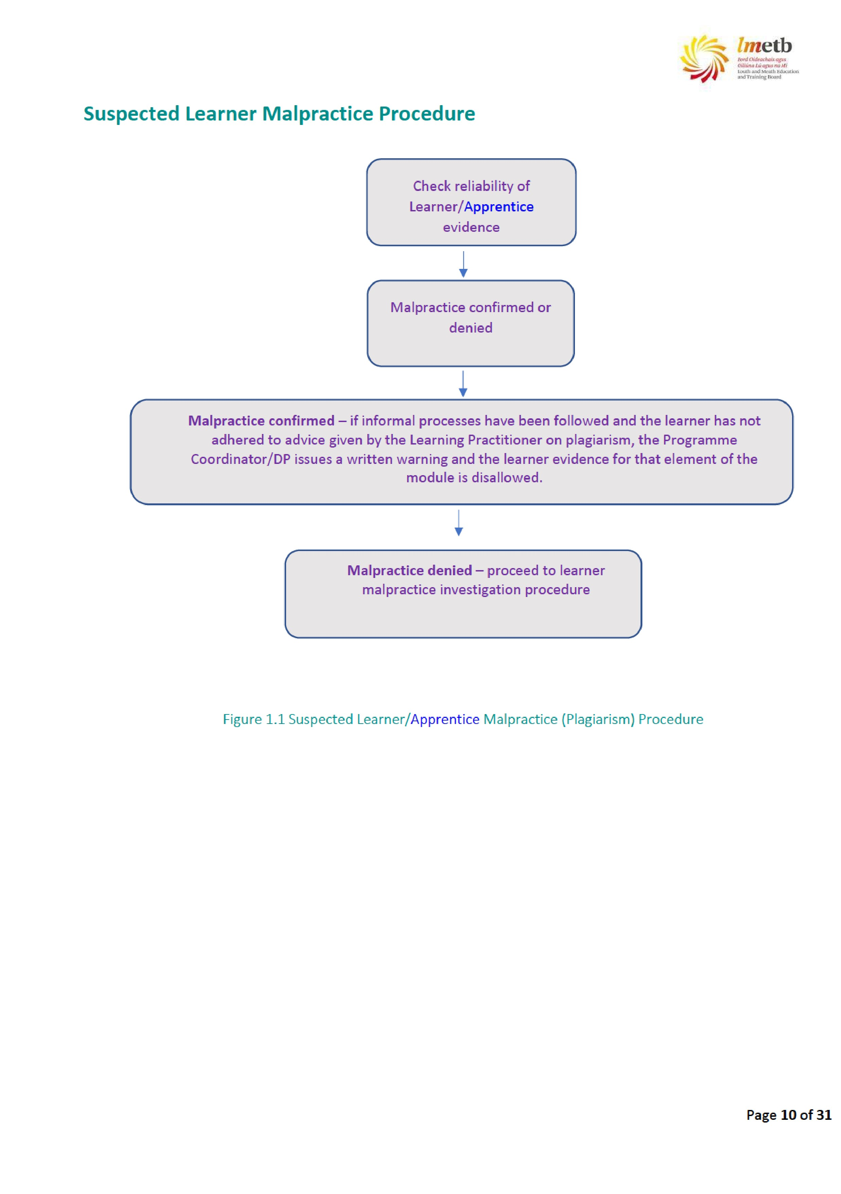
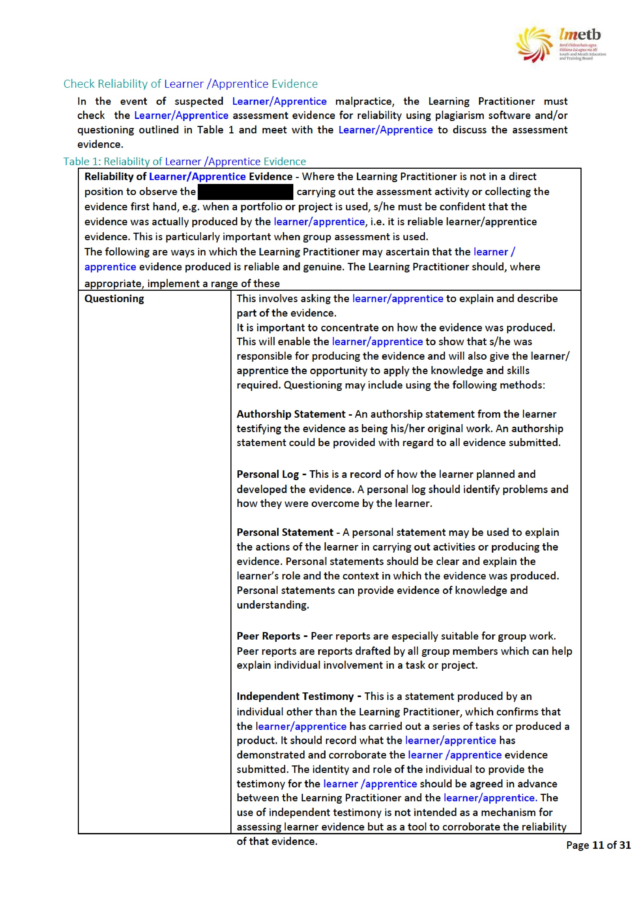
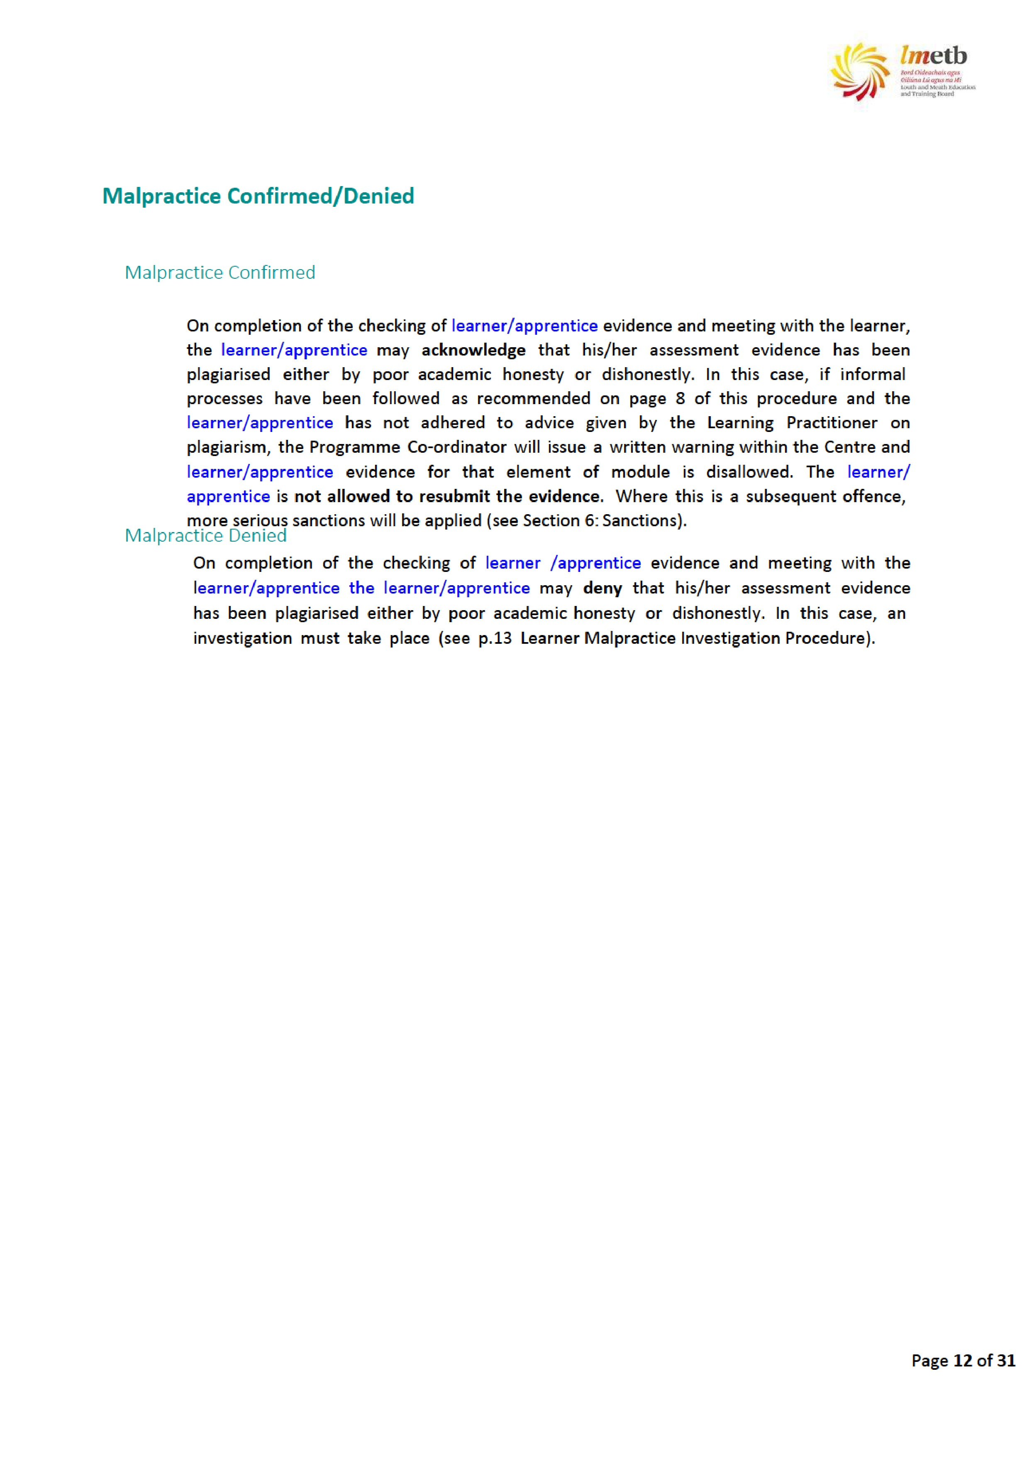
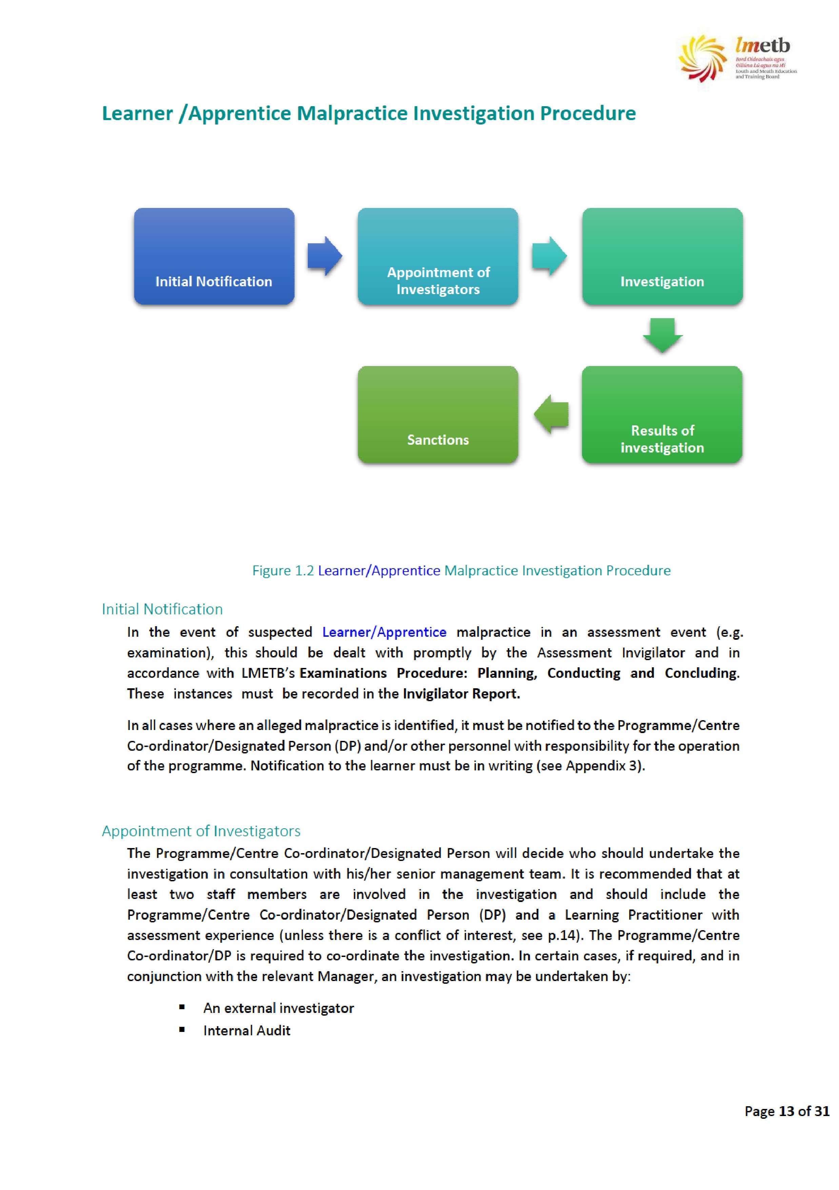

The Programme/Centre Co-ordinator/DP must complete the Alleged Assessment
System Malpractice Report (see Appendix 1: Section 1: General). It is important that only one report per learner/apprentice is completed. If the alleged assessment system malpractice is suspected for more than one learner/apprentice, separate forms must be used.
Any person who has a possible conflict of interest should not be involved in any investigation or subsequent making of judgments (see below for information on Conflict of Interest).

Conflict of Interest
Conflict of interest means any issue that might unfairly influence, or appear to influence, the outcome of an investigation. Possible Conflict of Interest relates to situations where personnel:
- Have a personal relationship or family relationship with the learner /apprentice being investigated
- Have a professional relationship with the learner/apprentice being investigated that may be perceived to unfairly influence the investigation process
The Programme/Centre Co-ordinator/DP shall be responsible for ensuring that a conflict of interest does not arise and that all members of an investigation panel sign a declaration to that effect (see Appendix 2). In cases where conflict of interest is identified, alternative arrangements must be put in place.

Natural Justice
Those responsible for conducting an investigation shall establish the full facts and circumstances of any alleged assessment system malpractice. It should not be assumed that an allegation equates to proof of a malpractice. Any investigation into an alleged malpractice shall have due regard to the principles of natural justice. As such, it is necessary that those responsible for managing the conduct of any investigation must ensure adherence to these principles. This includes ensuring that:
- All investigations do not disadvantage the person against whom the allegation is made and are concluded within a reasonable timeframe (it is expected that this should be completed as promptly and as efficiently as possible except in exceptional circumstances which may take a maximum of 40 working days) from the date of the notification to the Centre Manager of the alleged malpractice
- The learners/apprentice candidates in question are made aware of the allegation and are given the opportunity to respond
- Care is taken to avoid conflict of interest (see above)
The learner/learners /apprentices against whom an allegation is made should therefore:
- Know what evidence exists to support that allegation
- Know the possible consequences should an assessment system malpractice be proven
- Have the opportunity to consider their response to the allegations (if required)
- Have an opportunity to submit a written statement
- Have an opportunity to seek advice (as necessary) and to provide a supplementary statement (if required)
- Be informed of the applicable appeals procedure, should a decision be made against him or her
Be informed of the possibility that information relating to a particular malpractice may be shared with other relevant parties

Investigation
All notified alleged assessment system malpractices must be investigated.
It is expected that the investigation should be completed as promptly and as efficiently as possible except in exceptional circumstances which may take up to a maximum of 40 working days from the date of the notification to the Centre Manager of the alleged malpractice.

Communication with Learner/Learners /Apprentice/Apprentices to be Investigated
The Programme/Centre Co-ordinator/DP shall be responsible for communicating in writing to the learner/apprentice to be investigated, in relation to the alleged assessment system malpractice(s).
The initial communication shall:
- Provide notification that an allegation of an assessment system malpractice has been received
- Advise that LMETB’s Assessment Malpractice Procedure will outline how the investigation will be conducted
- Emphasise that the investigation will be carried out in a discreet and confidential manner except in exceptional circumstances. Exceptional circumstances cannot guarantee this confidentiality as identity may need to be disclosed to:
  - An Garda Síochána, fraud prevention agencies or other law enforcement agencies (to investigate or prevent crime including fraud)
  - The courts (in connection with court proceedings) o Other person(s) to whom LMETB and/or awarding bodies are required by law to disclose identity
- Avoid implying or suggesting that conclusions have already been determined or that decisions have been made in respect of the application of corrective actions
Note: Template for this communication (see Appendix 3).

Establishing the Facts within the Investigation
The investigating team should endeavour to obtain all the relevant facts about the alleged assessment system malpractice. This may be done through some or all of the steps outlined below:
- Review of allegation details
- Interview with the learner /apprentice being investigated
- Interview with personnel and or management connected to the course, project or alleged malpractice
- Interview with learners/apprentices connected to the course, project or alleged malpractice
- Interview with the other relevant parties
- Written statement(s) from the learner being investigated
Written statement(s) from learners/apprentices connected to the course, project or alleged malpractice
- Written statement(s) from personnel connected to the course, project or alleged malpractice
- Written statement(s) from other relevant parties
- Review of related assessment reports
- Review of previous learner/apprentice record to seek to establish whether there has been any previous malpractice investigations previously for this learner/ learners/apprentice/apprentices
- Other related records Confidentiality
Confidentiality is a key aspect in the conduct of an investigation into an alleged malpractice, due to the risk of reputational damage to learners involved. In order to ensure confidentiality is maintained before, during and after an investigation, the following conditions should apply:
- Material relating to any allegations, findings or conclusions must not be made known to any parties, either internally or external to the Centre, beyond those key to the investigation
- It is not necessary to inform all learners/apprentices being interviewed of the details of meetings with other parties unless there is a specific relevant matter to be raised
- The name or other details of the learner making the malpractice allegation should not be divulged to the learner/learners /apprentice/apprentices to be investigated without consent
- All material relating to the investigation must be held and stored in a secure manner. Material relating to a given investigation should be stored together on a
Results of Investigationsingle file. Each file should have a unique code to identify the investigation. Copies of electronic material should also be held with this file

The Investigation Report
Typically, the Investigation Report (see Appendix 1: Section 2: Investigation Report) that results from the investigation of an assessment system malpractice shall contain the following:
- Number of learners/apprentices affected and/or implicated
- How the alleged malpractice was identified and notified to the relevant Programme/Centre Co-ordinator/DP. The nature of the malpractice and the specific assessment procedure(s) or assessment rule(s) or assessment regulation(s) that has/have allegedly been breached, as well as the award details
- Details of the scope of the investigation carried out ▪ The findings:
− details of the procedure, rule and/or regulation that is alleged to have been breached
− a statement of the facts as described by all parties
− details of any mitigating factors.
- Any recommendations based on the findings
Conclusion (whether the malpractice allegation is substantiated or unsubstantiated)
While the investigating team are required to make recommendations based on the findings, the team should not adjudicate on the report findings.
The report will be signed and dated by the investigating team. Any written statements notes of interviews or other relevant documentation reviewed or obtained as part of the investigation must be filed separately and securely as part of the investigation process.

Report Findings Adjudication
The Investigation Report is submitted to the relevant Programme/Centre Co- ordinator/DP. The relevant Programme/Centre Co-ordinator/DP adjudicates on the report findings and notifies the person(s) involved in writing as to whether the allegation has been substantiated or not. Where the allegation is substantiated, the notification will include details of the appeal process in regard to the findings and the sanctions/consequences for this breach of the assessment malpractice. The Programme/Centre Co-ordinator/DP must complete the Findings Adjudication and Communication of Findings Report (see Appendix 1: Section 3: Findings Adjudication and Communication of Findings).

Communicating the Results
The relevant Programme/Centre Co-ordinator/DP is responsible for ensuring that the notification of the alleged assessment system malpractice investigation finding is communicated to the relevant learners within a defined of timeframe ten (10) working days from the date of receipt of the investigator’s report.
The finding of an investigation into an alleged assessment system malpractice may be: ▪ Unsubstantiated Assessment System Malpractice ▪ Substantiated Assessment System Malpractice.
Note: Template for this communication (see Appendix 4).

Unsubstantiated Assessment System Malpractice
If the assessment system malpractice is found to be unsubstantiated, the relevant Programme/Centre Co-ordinator/DP will convey the findings of the investigation, in writing and within the timeline specified, to the learners/apprentice(s) involved. A record of the investigation is kept on file.
The learners'/apprentices' assessment evidence is accepted by the Centre/College and should be marked and graded in accordance with the standards of the award. The actual marks and grade awarded are determined solely on the basis of the evidence submitted in accordance with the standards for the award. There is no mark/ grade penalty under this procedure.

Substantiated Assessment System Malpractice
Where the allegation is substantiated, the relevant Programme/Centre Co-ordinator/DP will convey the findings of the investigation, in writing and within the timeline specified, to the learners/apprentices involved and should include details of the sanctions/ consequences of the assessment system malpractice.
In addition, the notification to the person must also outline the Assessment System

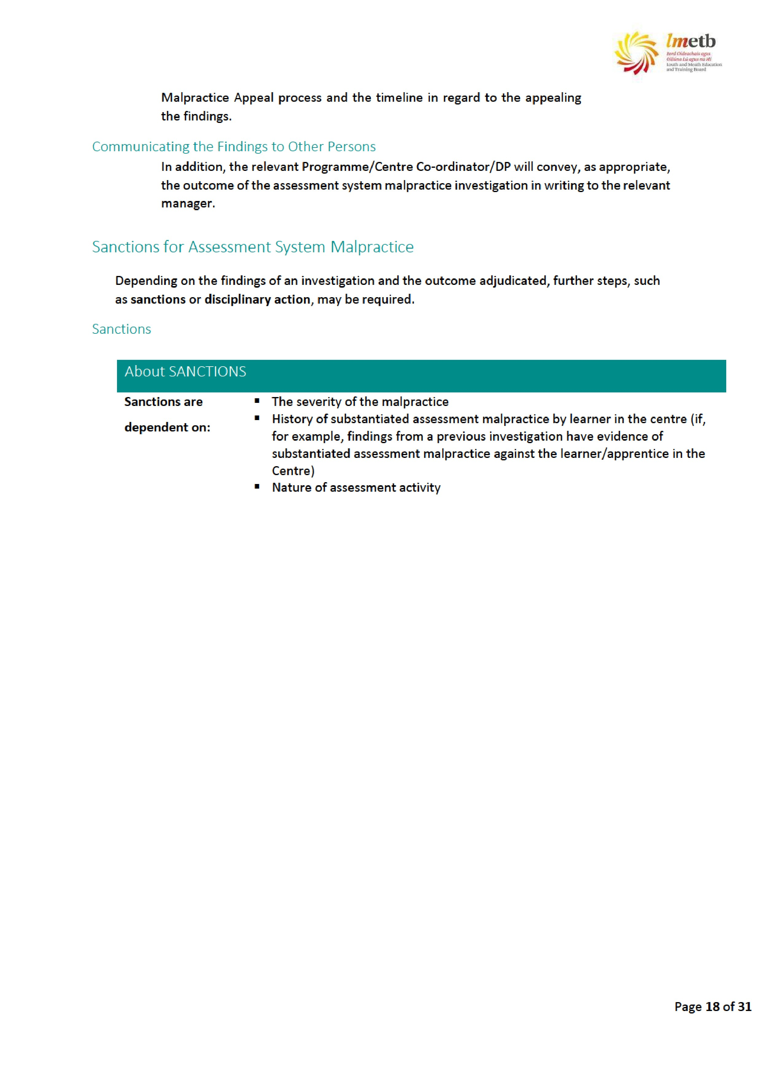
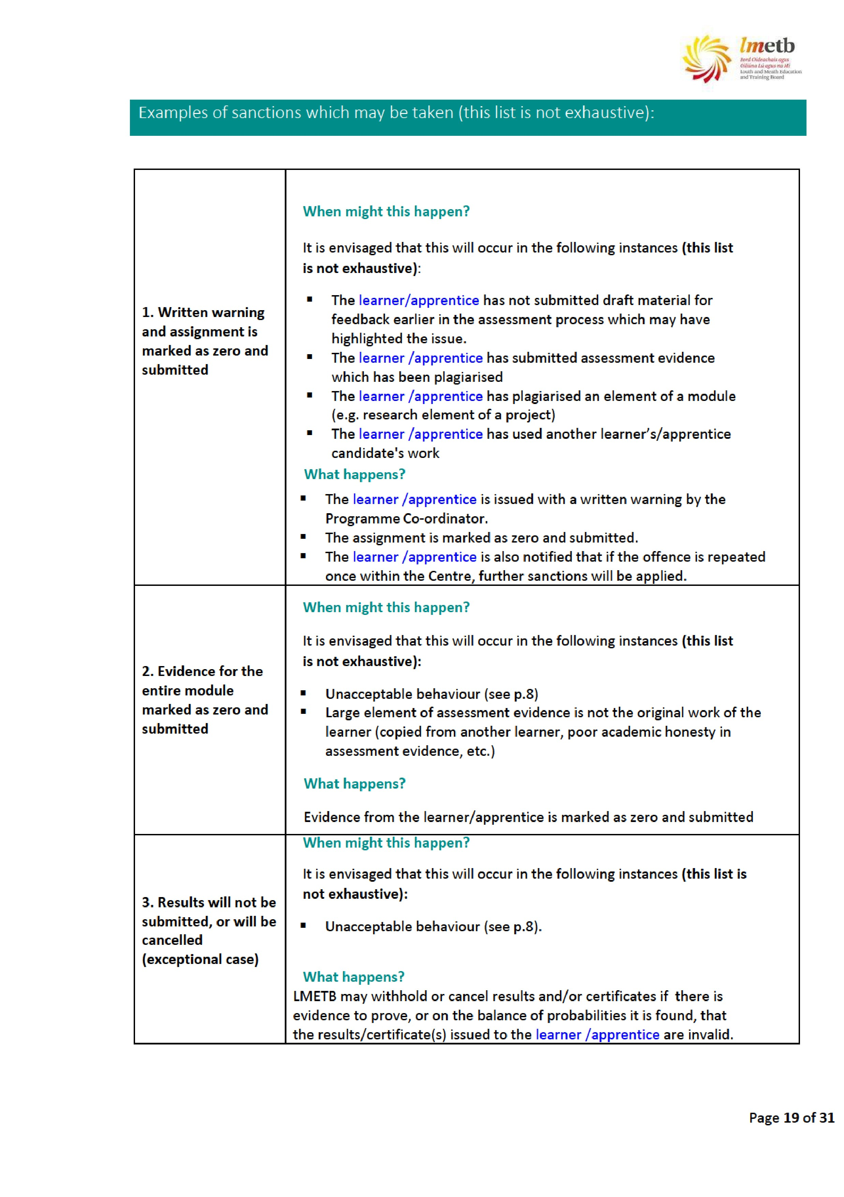
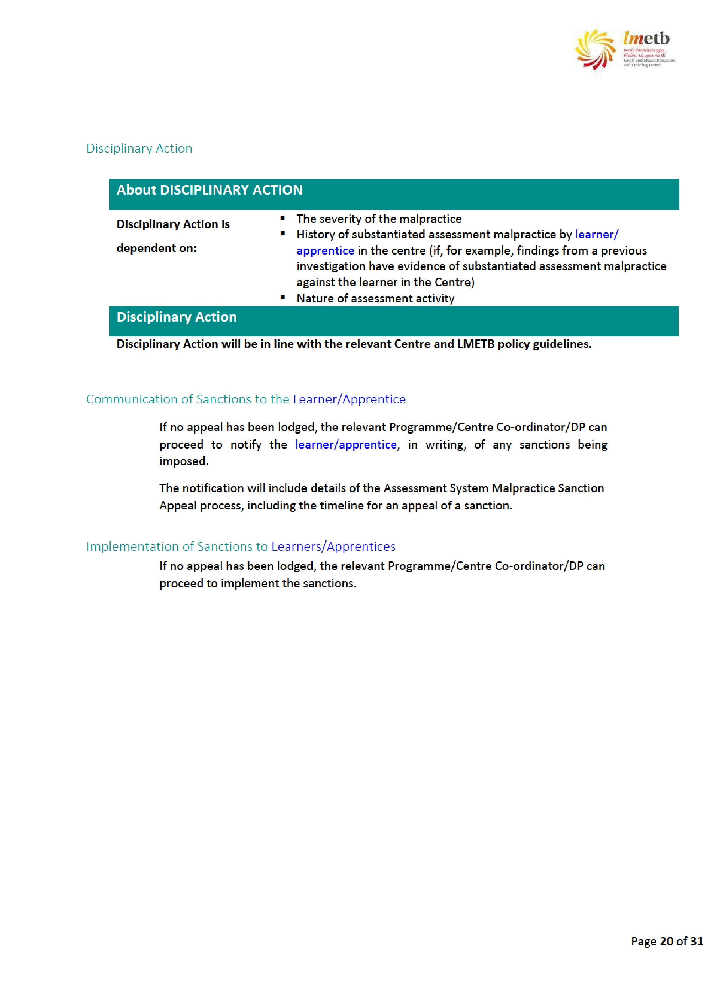

Appeals of Assessment System Malpractice Finding
The learner /Apprentice has the right to appeal the decision in relation to assessment deadlines. Appeals must be made within five (5) working days of the decision. In exceptional circumstances the Programme/Centre Co-ordinator/DP may extend this. All appeals must be made in writing using the Appeals Assessment System Malpractice Application Form (see Appendix 5).
The grounds on which the appeal process can be activated are as follows:
- The alleged malpractice was not dealt with in accordance with fair procedures
- The regulations did not adequately cover the circumstances relating to the malpractice
- New information has become available that was not available to the investigation
- Decision was wrong and not supported by evidence
Decisions on appeals are final.

References
QQI (2018 Revised) Quality Assuring Assessment Guidelines for Providers. Ireland: QQI. Available from: QQI Quality Assuring Assessment Guidelines (2013, Revised 2018)

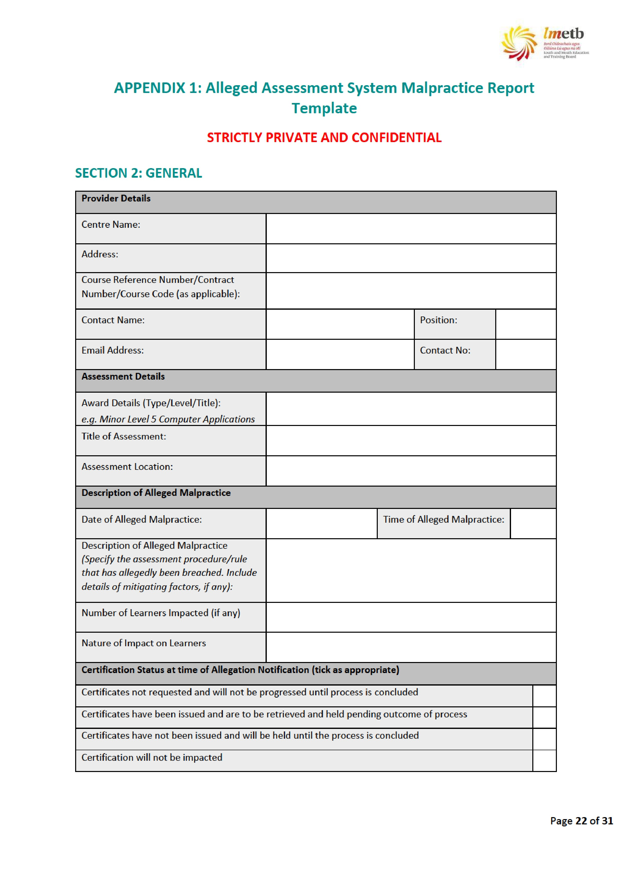
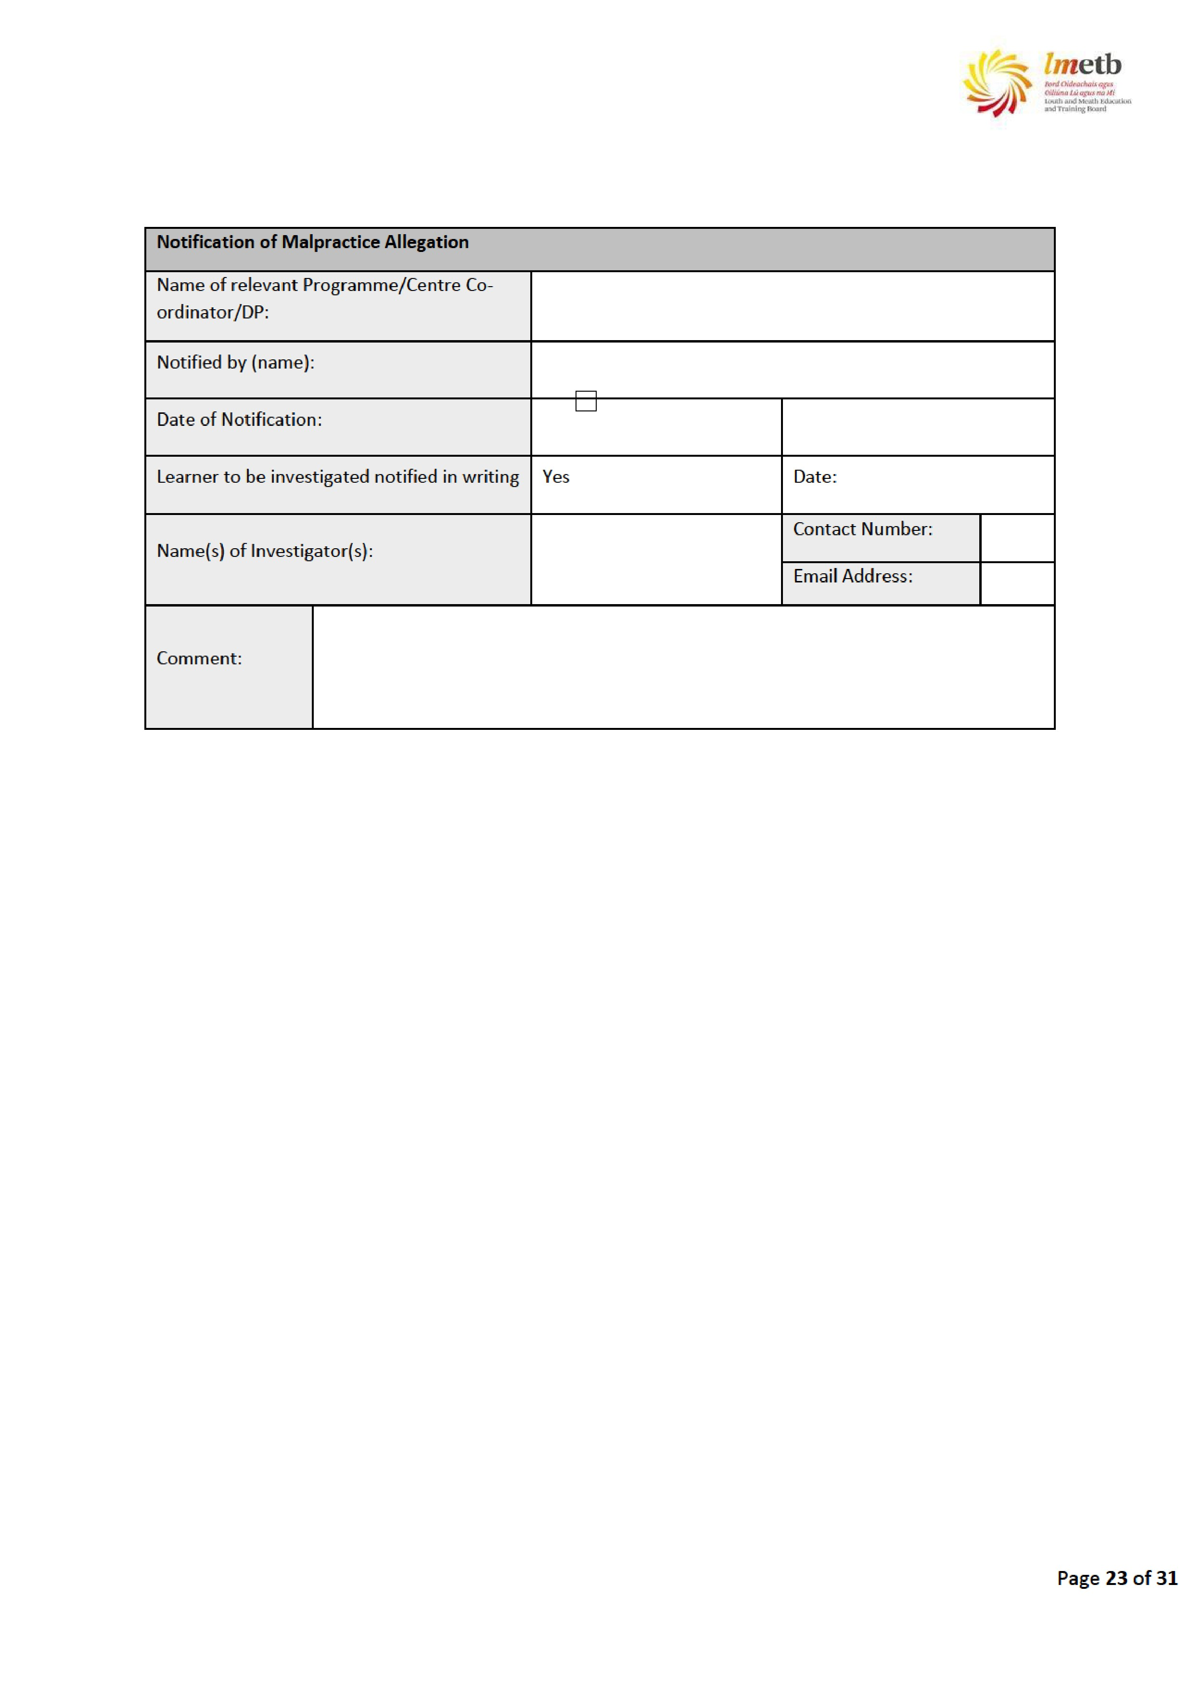
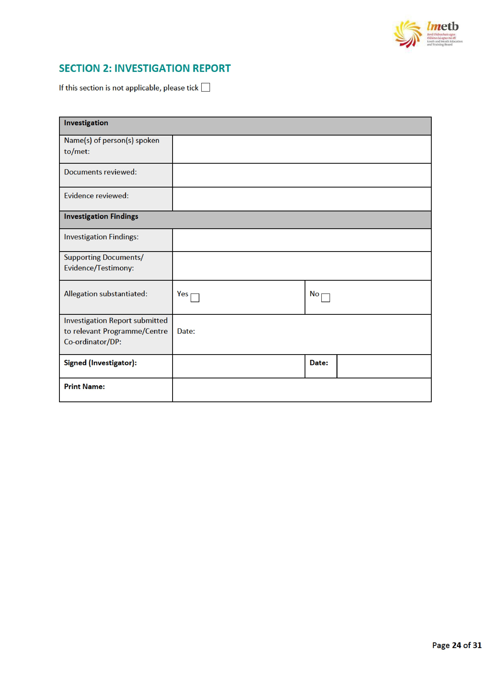
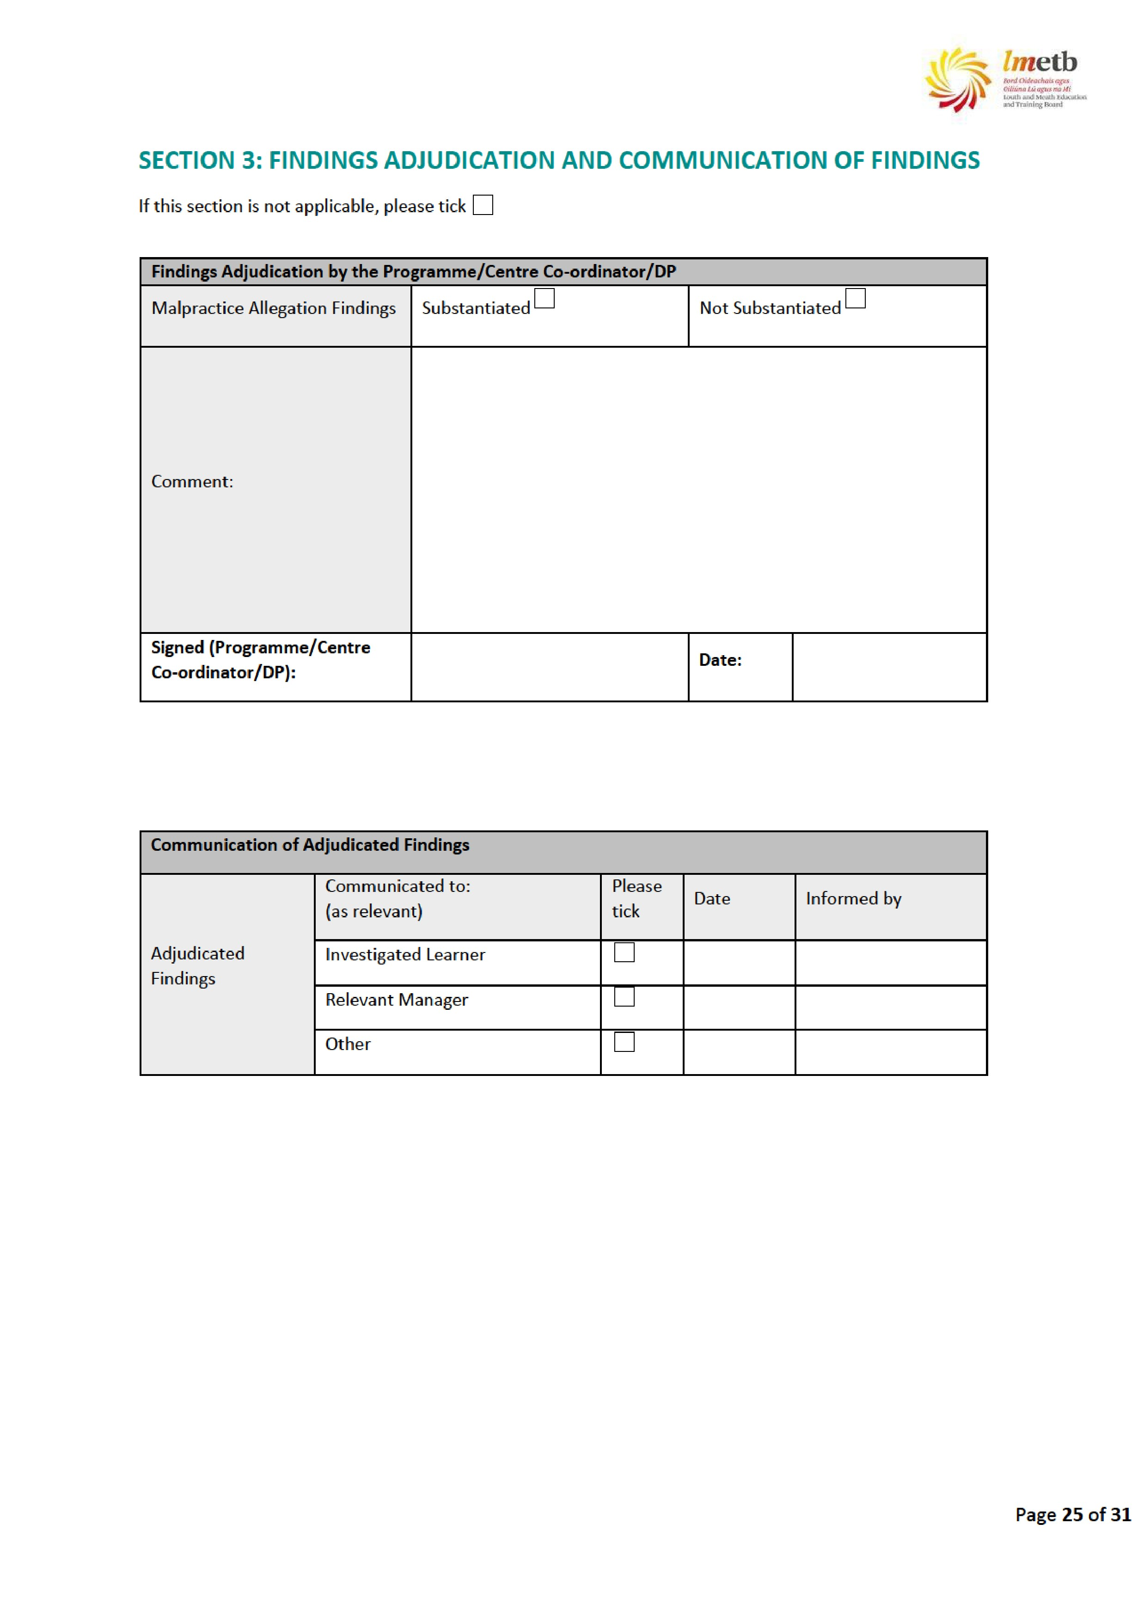
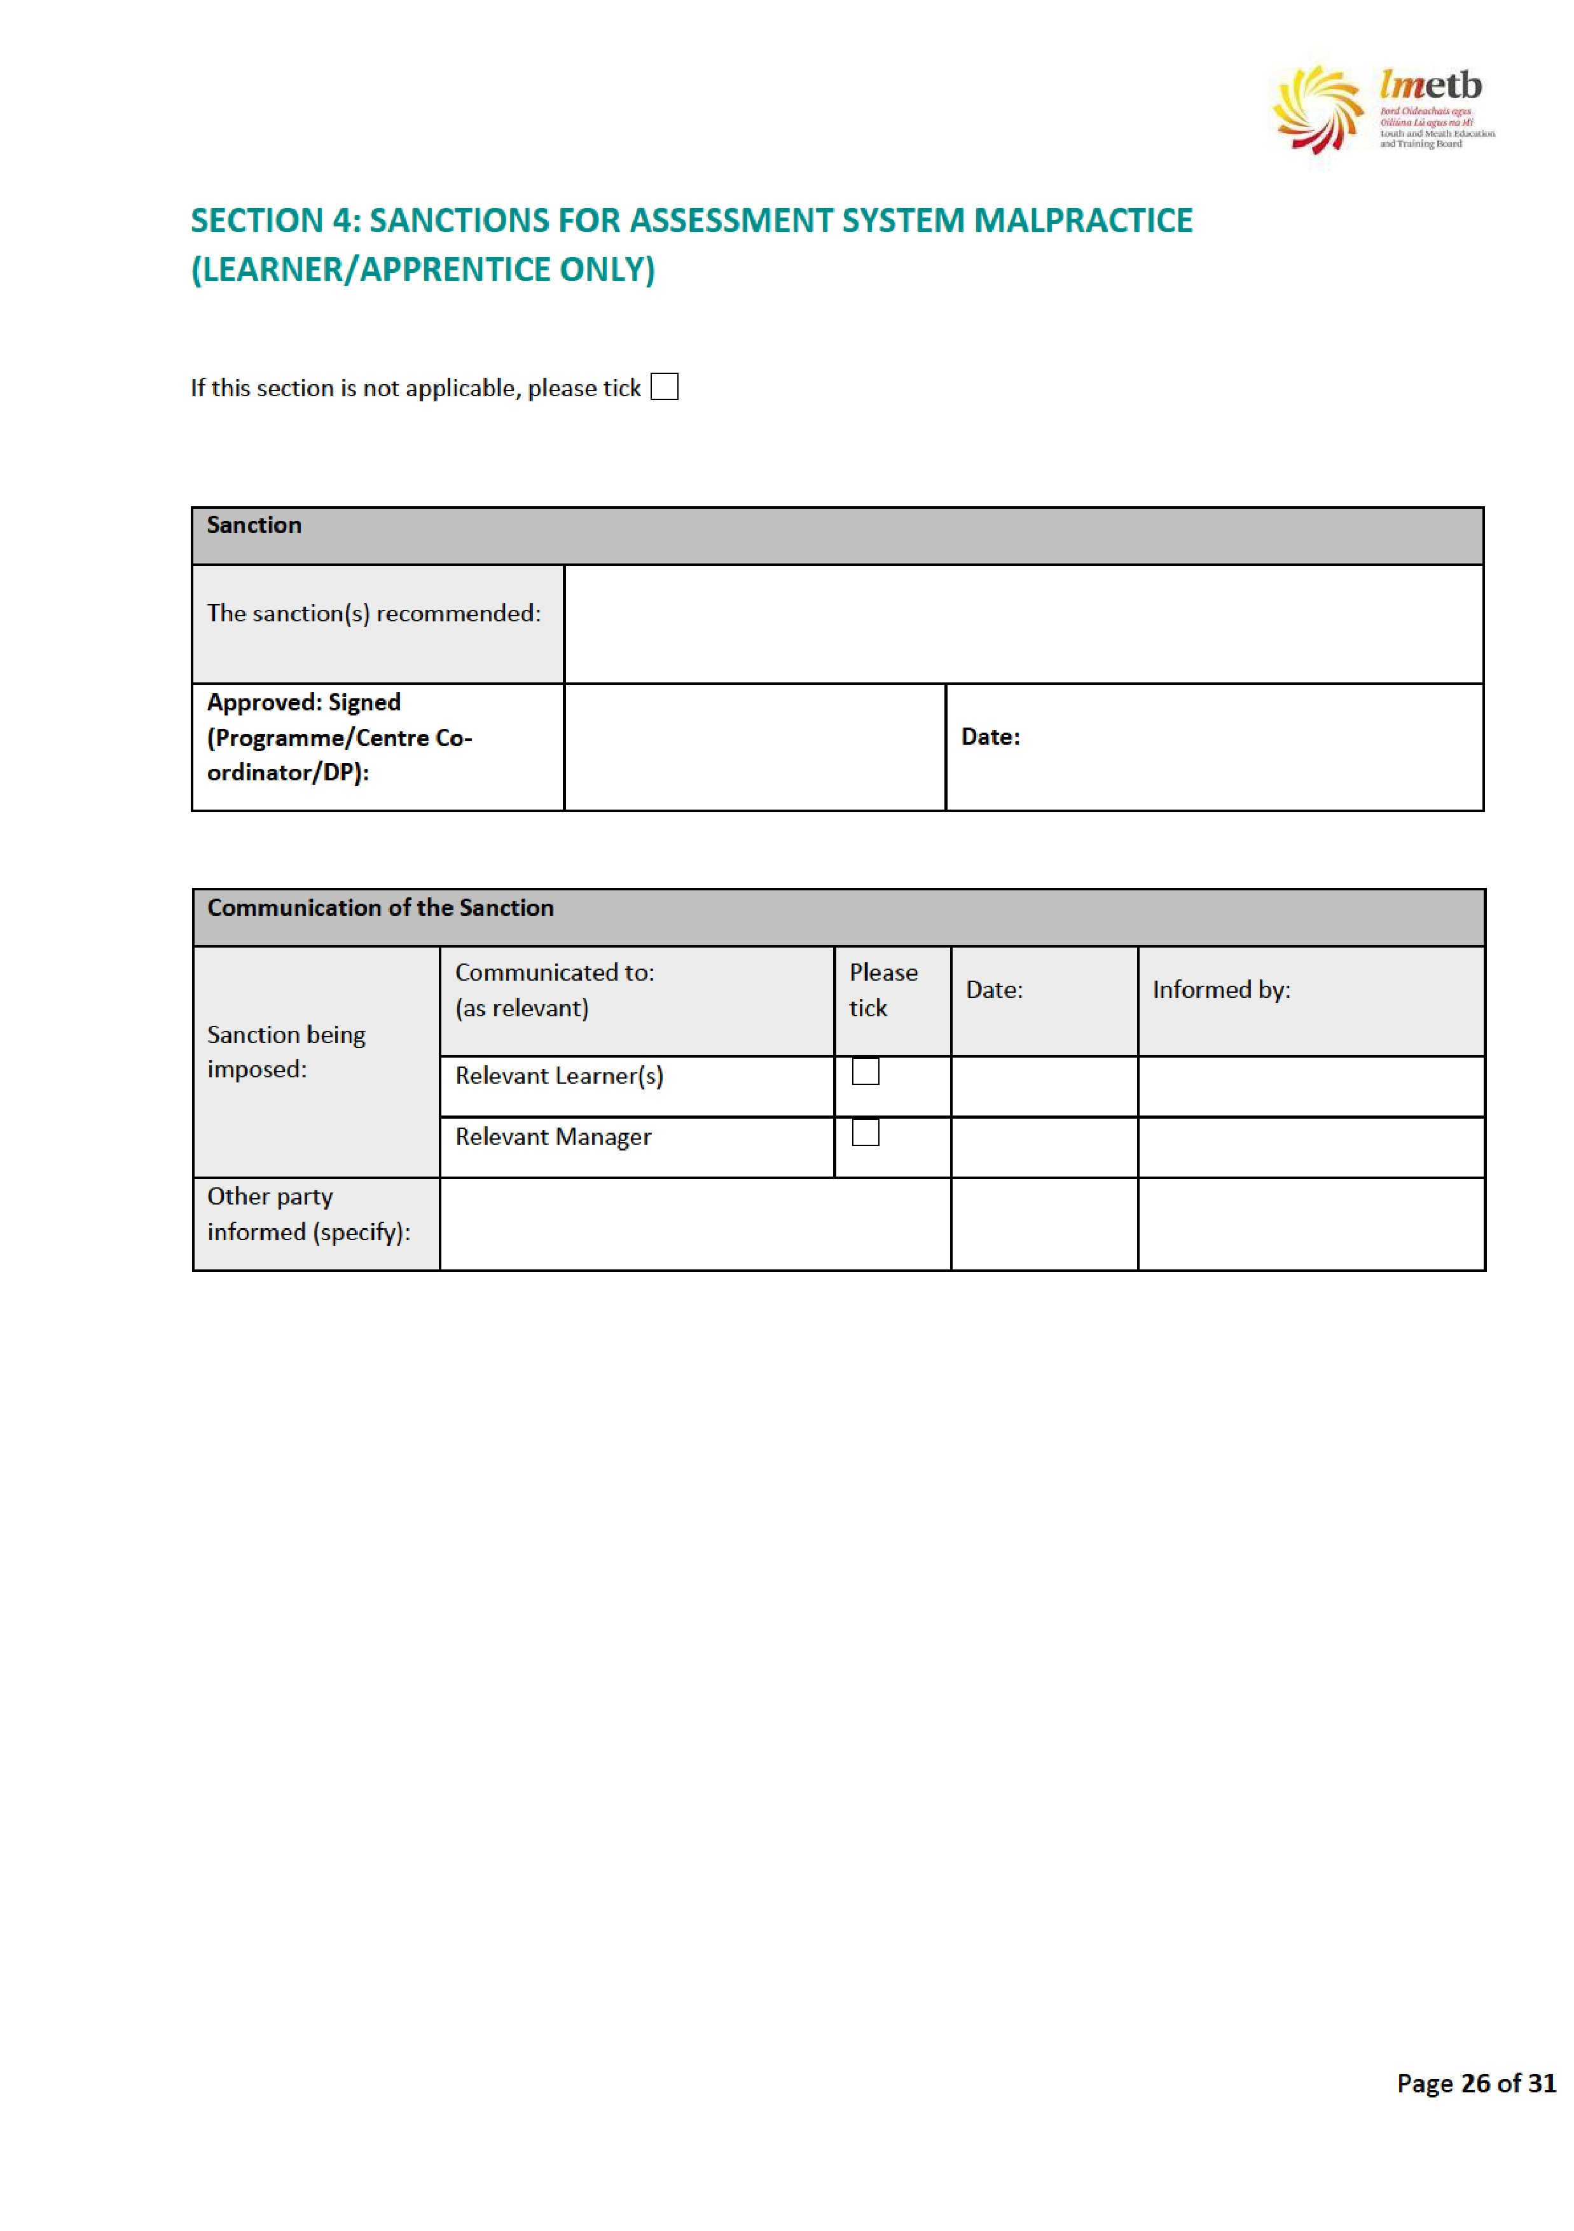
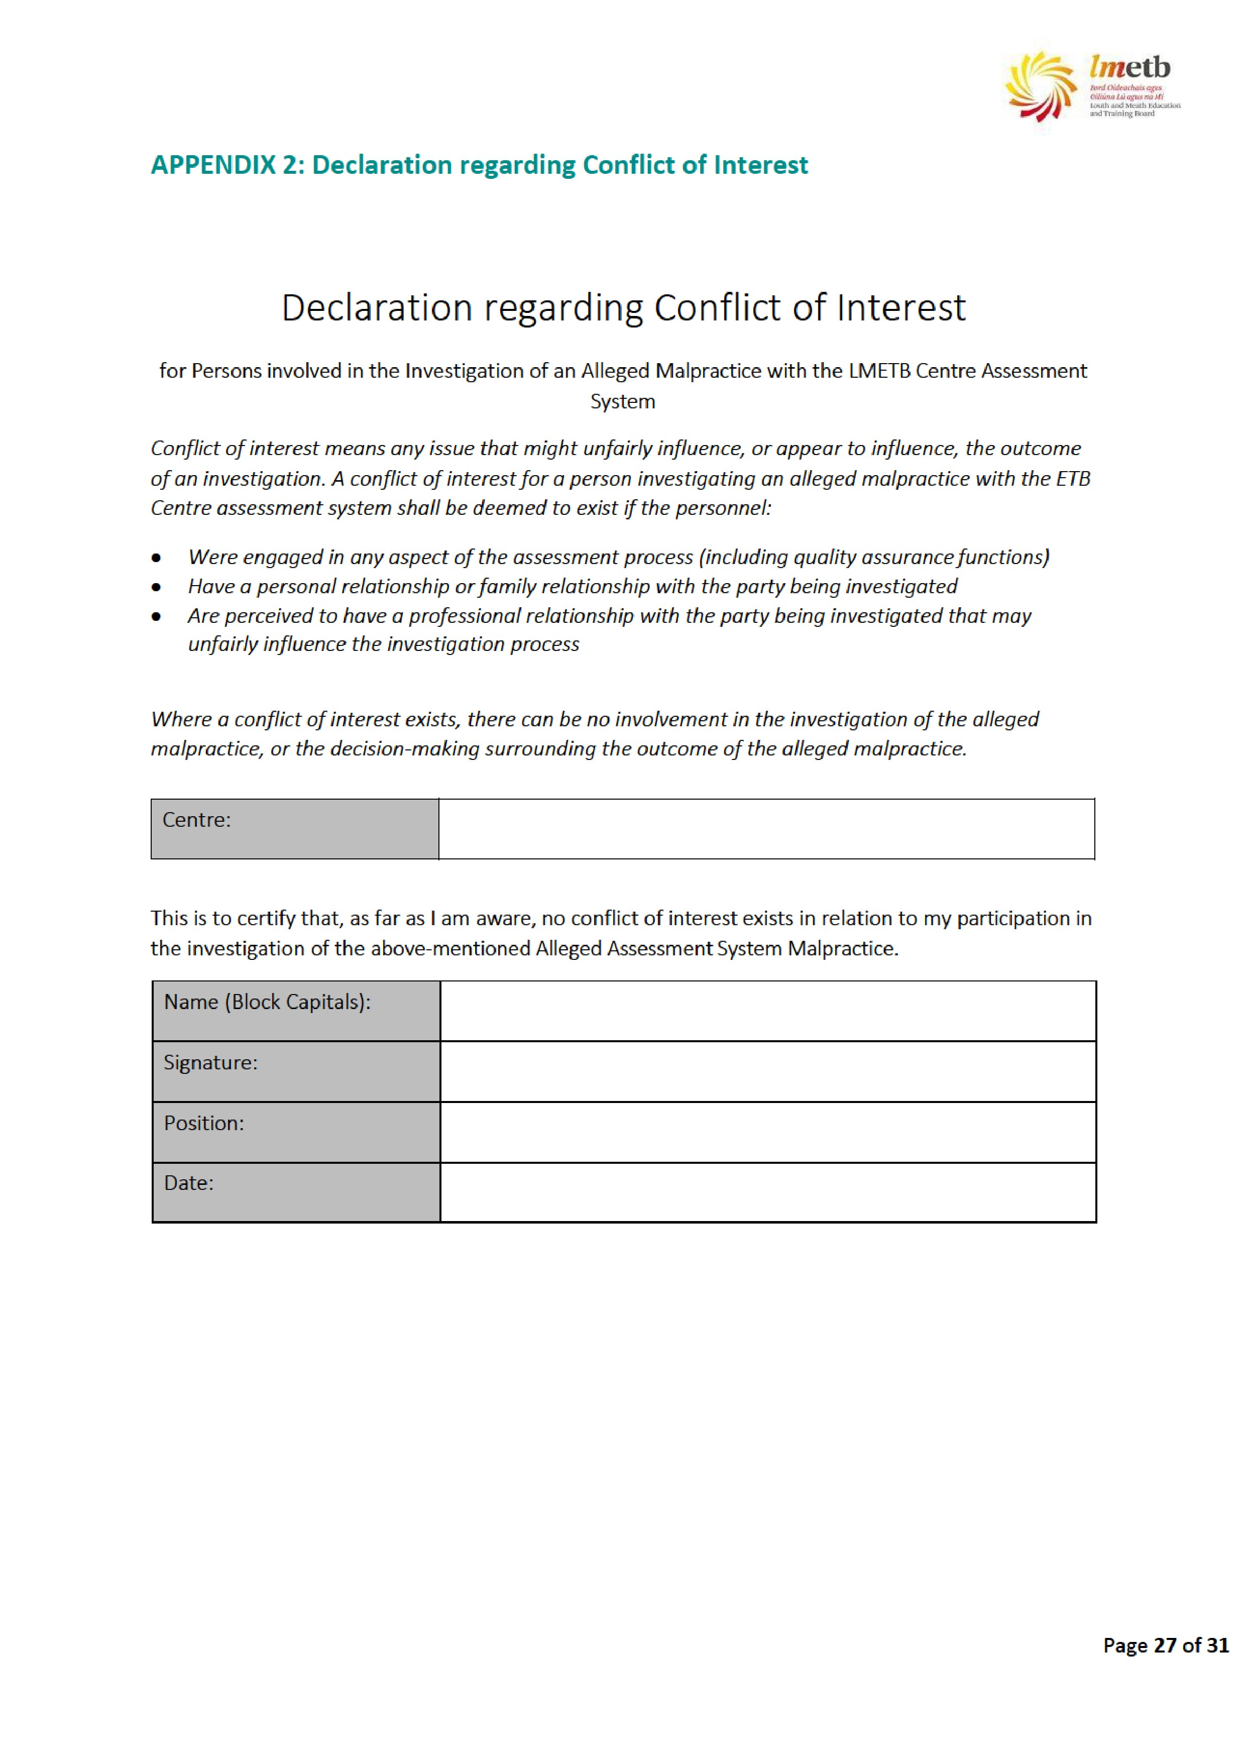

APPENDIX 3: Notification of Investigation Letter Template
NAME
COMPANY NAME (if applicable)
ADDRESS 1
ADDRESS 2
ADDRESS 3
Reference Number:
Date: <dd/mm/yy>
Subject: Alleged Assessment System Malpractice
Dear Mr/Ms < Name>,
I wish to inform you that it has come to our attention that an assessment system malpractice may have occurred relating to: (delete as appropriate) <Assessment Title> held at <Location> on <date>.
<Assessment Event> | held at | <Location> | on | <date> | .
<other - specify what the alleged malpractice relates to, when and where it is alleged to have
occurred if known>
The < Centre Name> intends to conduct an investigation into the alleged malpractice in accordance with the LMETB Assessment Malpractice Procedure (copy attached). You will be contacted by the Investigator appointed to investigate the alleged assessment malpractice in due course.
I wish to assure you that the investigation will be carried out in a discreet and confidential manner, and will have due regard to the principles of natural justice for all parties concerned.
If you require any further information please do not hesitate to contact me. Please quote the reference number above in all your correspondence with the < Centre Name> in this regard. Yours sincerely
<Name>
Manager

APPENDIX 4: Notification of Assessment System Malpractice Finding Letter Template
NAME
ADDRESS 1
ADDRESS 2
ADDRESS 3
Reference Number:
Date: <dd/mm/yy>
Subject: Finding of the Alleged Malpractice Investigation
Dear Mr/Ms < Name>,
I am writing to tell you about the finding of our investigation into the malpractice allegation. We have <upheld / not upheld > (delete as appropriate) the allegation.
(In the case of an allegation that has been upheld)
<If you want to appeal this finding, you must complete the attached application form and return it to
me within five (5) working days from the date of this letter.
If you require any further information, please do not hesitate to contact me. Please keep this letter as you will need the above reference number to complete the appeal form (if you are taking one) and when you contact us on this matter.
Yours sincerely

<Name>
Manager
APPENDIX 5: Appeals of Assessment System Malpractice Application Form
Instructions
Please complete all parts of this form in BLOCK letters. Send it to the relevant Programme/Centre Co- ordinator/Designated Person who wrote to tell you about the assessment system malpractice finding. Please do this within five (5) working days from the date of their letter.
Nature of Appeal: | Appeal on Findings Appeal on Sanctions  (please tick one box)
Name:
Address:
Reference Number (you will find this on your letter):
Contact number:
Email address:
Reason for your appeal (please tick one box only)
Malpractice was not dealt with in line with the Centre procedures
Regulations did not adequately cover the circumstances around the malpractice
New information is now available that was not available to the investigation
Please explain your reason for this appeal application:
Print Name:
Signature: |  | Date:

